Westworth United Church
1750 Grosvenor Avenue, Winnipeg, Manitoba
on Treaty One Territory in the heart of the Métis Nation
15th Sunday after Pentecost
September 18, 2022

We Gather to Worship

Welcome

Candle Lighting: “Nimrod” from Enigma Variations Edward Elgar

Treaty Acknowledgement

Children’s Time

Hymn: VU 686 “God Grace and God of Glory” vs 1,3,4 RHUDDLAN

Prayer of Confession:
God of grace,
Grant us pause when reactive energy rises within.
When those in authority seed fear and anger with distortion,
Give us wisdom and courage to respond responsibly with compassion.
Help us resist the lure of dehumanizing the other.
Nudge us to pray for them as we pray for our own,
That all may receive your transformative love.

Silent Meditation

Words of Assurance

Passing the Peace:
May the peace of Christ be with you.
And also with you.
“I Vow to Thee, My Country” Gustav Holst

We Hear the Word

Scripture Readings: VU 835 “Psalm 113: Praise to the Lord”
I Timothy 2:1-7
Hear what the Spirit is saying to the Church
Thanks be to God.
Sung Response: VU 956 “Your Word is a Lamp”

Anthem: “Prayer of Being” Mark Hayes

Sermon: “Stone Catchers and Bridge Builders”

We Respond

Hymn VU 691 “Though Ancient Walls” vs 1,2,3 KARR

Offertory Prayer

Ministry of the People

Prayers of the People
Prayer Introit: MV 175 “May We but Wait”

Lord’s Prayer

Hymn VU 678 “For the Healing of the Nations” WESTMINSTER ABBEY

Benediction

Sung Response: “Hallelujah” ST. GEORGE’S

Postlude: “Westminster Abbey” Charles Callahan

Reader: Bettina N QR Code for Westworth donations
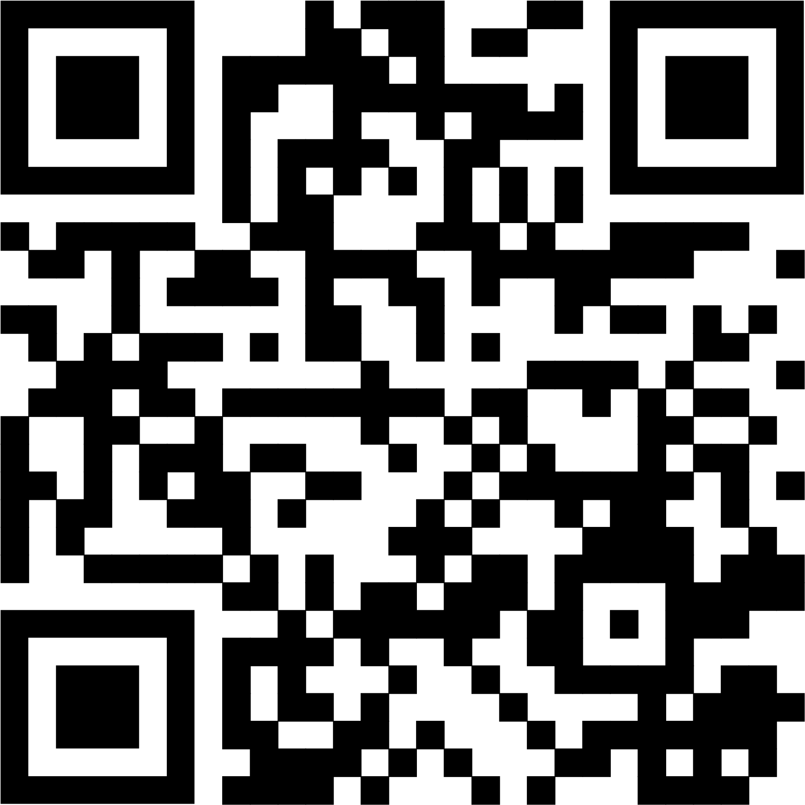
Director of Music: Bill Q
Organist: Dorcas W
Minister: Loraine MacKenzie Shepherd
Coordinator of Children, Youth and Family Ministries: Katie A

Scripture Response

At Westworth, we use three different types of responses to the scripture readings, to which we respond “Thanks be to God.”:

“This is the Gospel of Christ” is used after a reading from one of the four gospels of Matthew, Mark, Luke or John.

“Hear what the Spirit is saying to the Church” is usually used after a reading from the New Testament, other than the gospels.

“This is testimony to the Word of God” can be used after any reading.

The traditional response is “This is the word of God.” However, we do not believe that the Bible consists of God’s literal, infallible words. Rather, it is a record of people of faith who describe their faith experiences, based on the wisdom of their ancestors and the guidance of the Spirit. As Christians, we believe that their words are a testimony to God through Jesus the Christ.

The Gospel of John 1:1 reads, “In the beginning was the Word, and the Word was with God, and the Word was God.” The Word (notice that it is capitalized) in this passage refers to Jesus the Christ.

When we say “this is testimony to the Word,” we acknowledge that scripture is inspired human story that testifies to Jesus the Christ.

