Westworth United Church
1750 Grosvenor Avenue, Winnipeg, Manitoba
on Treaty One Territory in the heart of the Métis Nation
2nd Sunday of Advent
December 4, 2022

We Gather to Worship

Welcome & Announcements

Introit: “People Look East” French Folk Melody
harm. Martin Shaw

Candle Lighting: “Saviour of the Nations, Come” Samuel Scheidt

Treaty Acknowledgement

Hymn: VU 7 “Hope is a Star” vs 2 then 1 MOON BEAMS

Prayer of Confession
God of Advent waiting,
As we prepare our homes for the celebration of Christmas,
help us prepare our hearts.
Nudge us to protect spaces
for reflection and recentring of heart and mind.
Give us the courage
to face our own challenges and the challenges of the world.
Grant us the wisdom
to respond with compassion to ourselves and to others.

Silent Meditation

Words of Assurance

Passing the Peace of Christ
May the peace of Christ be with you.
And also with you.
“Lo, How a Rose E’er Blooming” arr. John Carter

We Hear the Word

Old Testament Scripture Reading: Isaiah 11:1-10
This is the testimony to the Word of God
Thanks be to God.

Responsive Reading: VU 8 “Lo, How a Rose E’er Blooming” EST IST EIN ROS
Gospel Scripture Reading: Matthew 3:1-8
This is the Gospel of Christ.
Thanks be to God.

Sung Response: VU 37 “Gloria” Jacques Berthier

Anthem: “O Savior, Rend the Heavens Wide”
Friedrich Von Spee/David Bridges

Sermon: “The Peaceable Kin-dom”

We Respond to the Word

Hymn: VU 28 “Herald! Sound the Note” vs. 1-3
NEANDER/(UNSER HERRSCHER)

Offertory Prayer

The Sacrament of Holy Communion (see insert)

Ministry of the People

Prayers of the People

Hymn: VU 682 “O Day of Peace” JERUSALEM

Benediction

Sung Response: VU 38 “Gloria” Refrain GLORIA

Postlude: “Lo, He Comes with Clouds Descending”Morgana Graham

Reader: Daryl Brooks
Candle lighters: Brett Lougheed, Denise Jones & family
Camera & Production: Kim O’Grady & Grace Jeffers
Interim Director of Music: Ruth Wiwchar
Organist: Dorcas Windsor
Minister: Loraine MacKenzie Shepherd
Thank you to our Communion Servers QR Code for Westworth donations

Minute for Mission
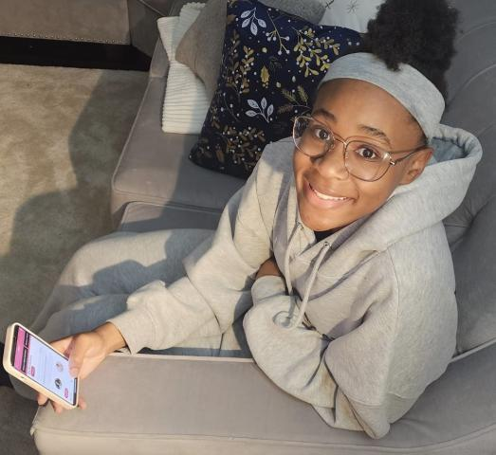
“After what happened to George Floyd, I wanted to get involved.”

The murder of George Floyd had a profound affect on Jonisha Lewinson, a college student and member of North Bramalea United Church. “Although I had experienced racism, I hadn’t been interested in exploring it, but after what happened to George Floyd, I wanted to get involved,” she says. “I decided I wanted to not just have a quiet voice but an active voice in making information about anti-racism available to people.”
Shortly after she made that internal commitment, a friend told Lewison that the United Church was inviting young people to apply to the Young Black Scholarship Program project, part of the church’s commitment to the United Nations International Decade for People of African Descent. Each of the participants were tasked to research and report on various aspects of Black experiences in Canadian churches and received a scholarship supported through your Mission & Service gifts for their work.
From there, the idea for an app-based curriculum that would inspire teens ages 12─18 to become anti-racist was born.
Jonisha landed the contract to develop the curriculum for the app and is currently one of four young adults leading the project. Through the app, teens learn about topics like the history of racism in Canada, White privilege, and how to get involved in anti-racism work. Each of the units includes audio, video, and chat features. Called ar4yt (short for “Anti-Racism for Youth Training”), the app is set to launch January 1, 2023, and will be freely available on Google Play and the App Store.
“I’ve never written a curriculum before, so there was a lot of research. It was a big learning experience not just in creating the curriculum but learning about how racism affects different people in Canada other than myself,” reflects Jonisha.
What does she hope young people will take from the experience with the app?
“Part of dismantling racism means having conversations on a smaller scale with friends and family. That means just as much as being part of huge organizations. I hope that young people engaging with the app realize that making change is not as difficult as it seems,” she says.

