Westworth United Church
1750 Grosvenor Avenue, Winnipeg, Manitoba
on Treaty One Territory in the heart of the Métis Nation
3rd Sunday of Advent
December 11, 2022

We Gather to Worship

Welcome & Announcements

Introit: “People Look East” French Folk Melody
harm. Martin Shaw

Candle Lighting: “Mary, Woman of the Promise” A Fedak/M Graham

Treaty Acknowledgement

Hymn: VU 7 “Hope is a Star” vs. 3, 2, & 1 MOON BEAMS

Prayer of Confession
God of mercy,
Grant us courage to face life’s challenges
And not deny, downplay or ignore them.
Grant us the ability to receive what comes
With open hearts and open minds.
Help us welcome our deepest fears
That they may be reduced in intensity
And released into your hands.

Silent Meditation

Words of Assurance

Passing the Peace of Christ
May the peace of Christ be with you.
And also with you.
“I Wonder as I Wander” arr. Douglas Smith Bettina Nyman, flute

We Hear the Word

Gospel Scripture Reading: Luke 1:26-38
This is the Gospel of Christ.
Thanks be to God.

Sung Response: VU 37 “Gloria” Jacques Berthier

Anthem: “Ave Maria” Javier Busto

Sermon: “Courageous Mary”

Hymn: VU 899 “Song of Mary” vs. 1-3 Miriam Therese Winter

We Respond to the Word

Hymn: VU 23 “Joy Shall Come” vs. 1-3 ISRAELI TRADITIONAL

Offertory Prayer

Ministry of the People

Prayers of the People

Hymn: VU 64 “O Little Town of Bethlehem” vs. 4 ST. LOUIS

Hymn: VU 16 “Mary, Woman of the Promise” GRATIA PLENA

Benediction

Sung Response: VU 38 “Gloria” Refrain GLORIA

Postlude: “The King Shall Come when Morning Dawns”
arr. David N. Johnson

Reader: Shirley Watts
Candle Lighters: Andrea Wilkie Gilmore, Vaughn and Rowan
Camera & Production: Steve McClelland & Walter Watts
Interim Director of Music: Ruth Wiwchar
Organist: Dorcas Windsor
Flute: Bettina Nyman
Minister: Loraine MacKenzie Shepherd QR Code for Westworth donations

Minute for Mission
Children are the most vulnerable group in Colombia.
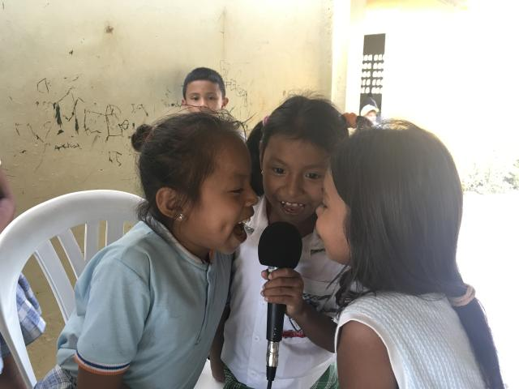
Children record radio programs through CEPALC.
We all know what it’s like to feel our spirit lift at the first note of music or to sense our minds being pried open by an enlightening radio or television show. Deep down we know that art changes our lives.
For hundreds of children living in Córdoba, Colombia, arts programs supported through your Mission & Service gifts teach children about their rights, give them an opportunity to express themselves, and promote peace-making as well as gender justice.
“Providing workshops for children that teach them about their rights empowers them to think critically about themselves and their country. Through media, art, music, and theatre, they learn about important social issues, human rights, and gender equality,” says the Latin American Center for Popular Communication (CEPALC).
Children are the most vulnerable group in Colombia. Eighty-four percent of violent acts in Colombia are committed against children. Two and a half million children living there work to sustain their families. Many are forced into dangerous labour. That’s why CEPALC designs programs in sectors hardest hit by poverty and violence.
"I told my mom that we had seen some works of Mahatma Gandhi, Nelson Mandela, and Flora Tristan. I remember that they taught us that we must defend the rights of us women. What I like, in general, is that they taught us that we must make peace,” says Amelie, an eight-year-old girl who lives in Bogotá and workshop participant. “Thanks to CEPALC workshops, I’ll be a writer, and I will write things so that children will promote and defend peace, following Jesus’ examples. I will defend and promote our rights in my stories so that nobody can disrespect us or the rights that we have. When I am an adult, I won’t be doing violence against anybody.”

