Westworth United Church
1750 Grosvenor Avenue, Winnipeg, Manitoba
on Treaty One Territory in the heart of the Métis Nation

The Baptism of Jesus
January 8, 2023

We Gather to Worship

Welcome & Announcements

Candle Lighting
"Divinum Mysterium" Wilbur Held

Treaty Acknowledgement

Children’s Time with Asperging

Hymn VU 449 “Crashing Waters at Creation” Dunstan/Cross

Prayer of Confession
God of love and grace,
Help us know deeply and fully
that we are loved by you.
Help us accept that everyone else,
including those we fear or despise,
are also loved by you.
Forgive us when our love is limited.
Grant us the grace
to break down walls that divide.

Silent Meditation

Words of Assurance

Passing the Peace of Christ
May the peace of Christ be with you.
And also with you.
“O Morning Star, How Fair and Bright” Charles Callahan

We Hear the Word

Scripture Reading:
Isaiah 42:1-9
This is the testimony to the Word of God.
Thanks be to God.

Matthew 3:13-17
This is the Gospel of Christ.
Thanks be to God.

Sung Response: VU 895 “Gloria” Pablo Sosa

Solo

Sermon: Beloved to Love

We Respond to the Word

Hymn MV 161 “I Have Called You by Your Name” Damon/Fines

Offertory Prayer

Ministry of the People

Prayers of the People

Prayer Introit: VU 951 “Holy, Holy, Holy”

Hymn VU 100 “When Jesus Came to Be Baptized” (vs 1-4) WINCHESTER NEW

Benediction

Sung Response: VU 87 refrain “I am the Light of the World”

Postlude: “Christ, Whose Glory Fills the Skies” Charles Callahan

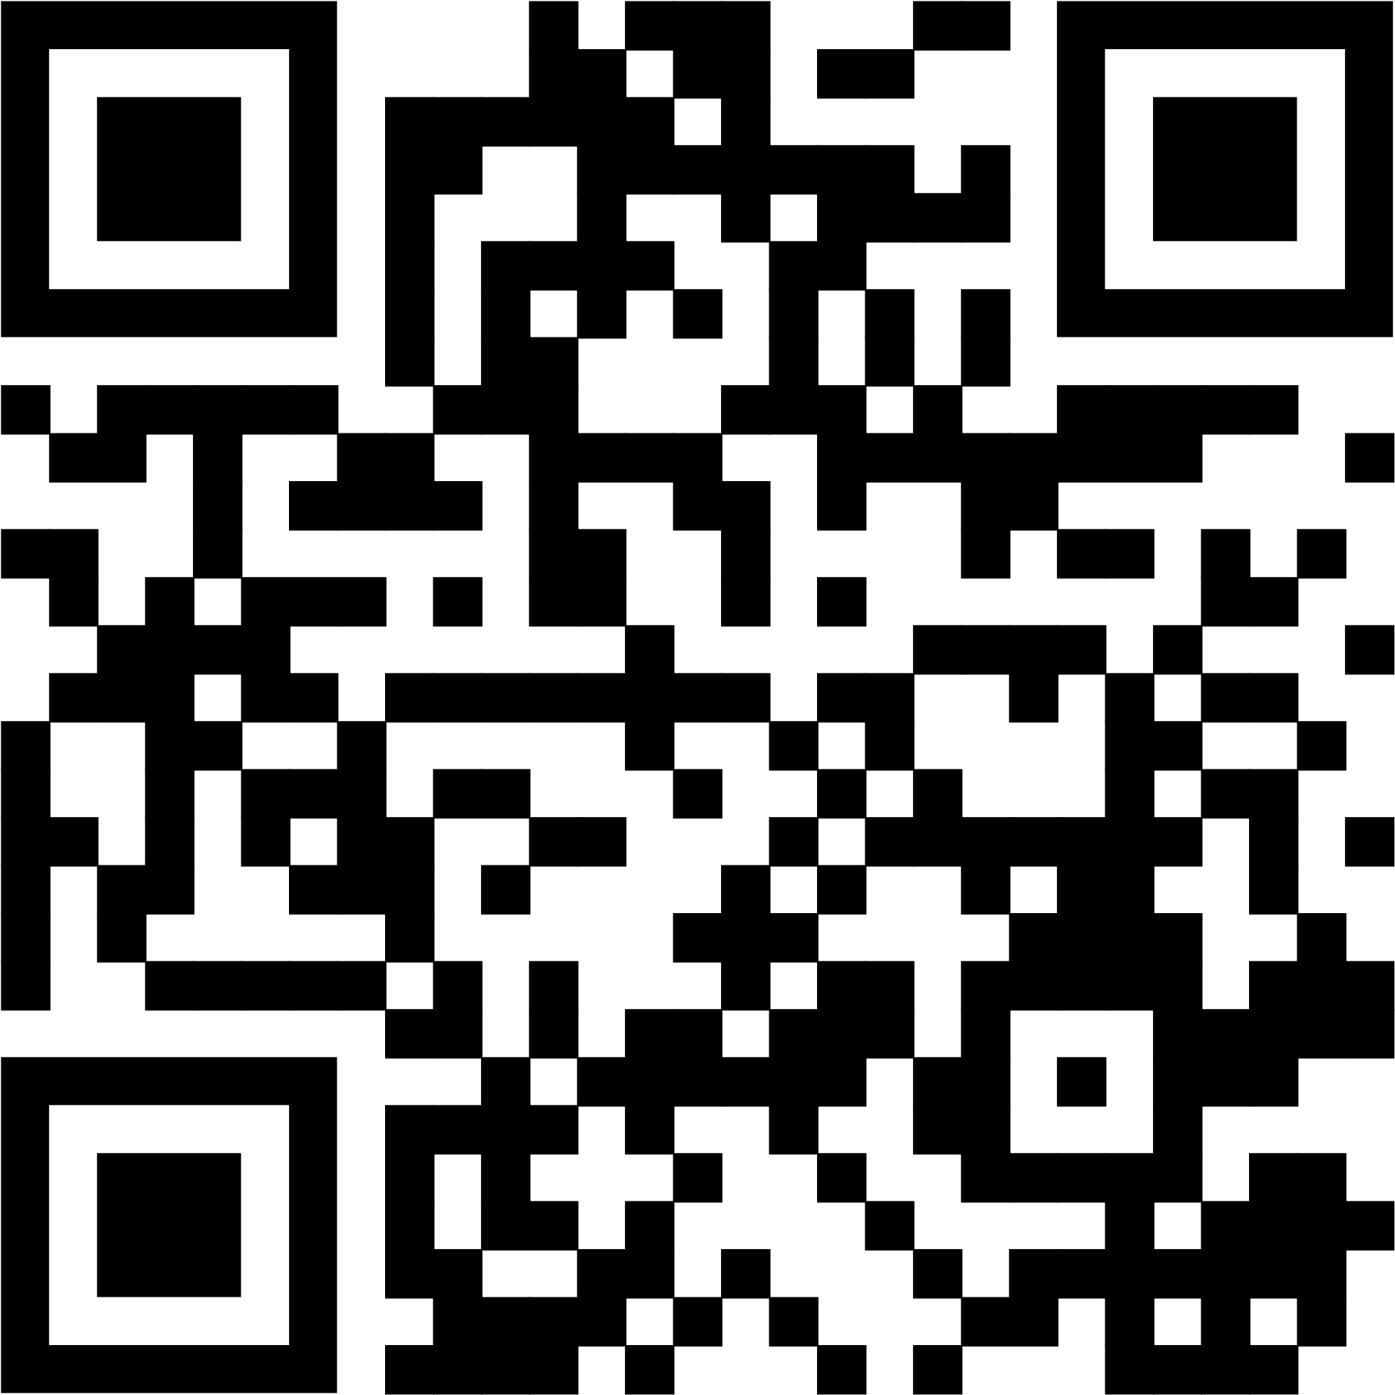
Reader: Kathy Wilson
Production & Camera: Peter Sims & Grace Jeffers
Interim Director of Music & Soloist: Ruth Wiwchar
Organist: Dorcas Windsor
Minister: Loraine MacKenzie Shepherd

QR Code for Westworth donations

