Westworth United Church
1750 Grosvenor Avenue, Winnipeg, Manitoba
on Treaty One Territory in the heart of the Métis Nation

January 29, 2023
4th Sunday of Epiphany

We Gather to Worship

Welcome

Introit: “You Are the Light” Tom Fettke

Candle Lighting
"When Morning Gilds the Skies” John Carter

Treaty Acknowledgement

Children’s Time: Sensei Tanis Moore – Paper Cranes

Hymn: VU 79 “Arise Your Light Is Come” FESTAL SONG

Prayer of Confession
Spirit of God,
Grant us the wisdom and fortitude
to do justice, love kindness and walk humbly with you.
As we work for justice,
remind us to be kind and humble.
As we offer kindness,
keep us mindful of the least in our midst
in a spirit of humility.
As we humbly recall our own weaknesses,
lead us past paralysis to actions that are just and kind.
Forgive us when we lose sight of the guiding light
That binds together justice, kindness and humility.

Silent Meditation

Words of Assurance

Passing the Peace of Christ
May the peace of Christ be with you.
And also with you.
“Lord, Whose Love Through Humble Service” arr. Chuck Marohnic
We Hear the Word

Scripture Readings:
Micah 6:1-8
This is testimony to the Word of God.
Thanks be to God.

Responsive Reading: VU 736 “Psalm 15”

Matthew 5:1-12
This is the Gospel of Christ.
Thanks be to God.

Sung Response: VU 895 “Gloria” Pablo Sosa
Anthem: “House Him There” Leland Sateren

Sermon: “Guiding Beacons of Light”

We Respond to the Word

Hymn: VU 701 “What Does the Lord Require of You” MOON
Jim Strathdee

Minute for the Environment: Frank Wynes

Offertory Prayer

Ministry of the People

Prayers of the People
Prayer Introit: VU 951 “Holy, Holy, Holy”

Hymn: VU 434 “O Laughing Light” ISTE CONFESSOR

Benediction

Sung Response: VU 87 “I Am the Light of the World” refrain

Postlude: “Iste Confessor” Healey Willan

Reader: Daryl Brooks
Production & Camera: Kim O’Grady & Grace Jeffers
Interim Director of Music: Ruth Wiwchar
Organist: Dorcas Windsor
Flute: Bettina Nyman
Coordinator of Children, Youth & Families: Katie Anderson
Minister: Loraine MacKenzie Shepherd
QR Code for Westworth donations

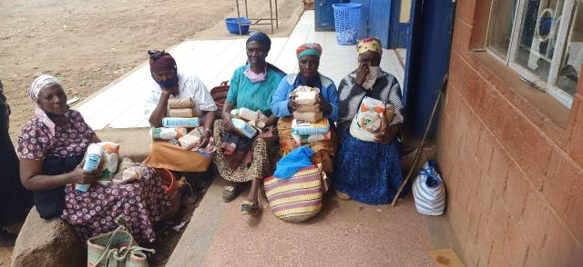
Grandmothers connect love for their grandchildren to God’s love for all.

Credit: World Council of Churches Ecumenical HIV and AIDS Initiatives and Advocacy
Published On: January 20, 2023
In the Rift Valley of Kenya, 7 percent of the people who live there are HIV positive—nearly 900,000—and many will not survive. Grandmothers whose children have died of AIDS are often left alone to care for their grandchildren, and to add insult to injury, their church community condemns them, leaving them without support as they raise their grandchildren. Some pastors in the Rift Valley, as in many other places, believe and teach that faithful Christians cannot contract the disease and that it is a judgment from God—a disease for sexual sinners. “The pastors had little information about HIV and AIDS; to them, and others in the community, it was a strange disease…. [They believed] HIV was a result of sexual sin and was a judgement from God for the sexually immoral,” writes Esther Mombo of the World Council of Churches. In partnership with the United Church, Mombo and Pauline Wanjuru of St. Paul’s University in Limuru, Kenya, led a series of workshops in one Rift Valley community that has been hit especially hard by HIV/AIDS. They invited grandmothers and pastors to connect and learn from each other. One grandmother who attended the workshops was 70 years old. She had lost both her daughter and her son and was left to raise three grandchildren on her own. Instead of stepping up to help, her neighbours refused to visit her because they said her daughter and son had been sexually immoral. Her pastor wouldn’t even attend her children’s funerals because he didn’t want to be seen associating with her family. When she went to church, the pastor preached about the punishment for sexual immorality. At the workshops, this woman bravely told her story to the pastors who attended. She also shared with them how it felt to be shamed for loving her children and grandchildren. Another grandmother explained that her grandchildren were born with the virus and couldn’t have been involved in any sexual immorality. Yet another spoke of God’s love for everyone. Pastors listened and learned, and ended by making a commitment to extend compassion and offer pastoral care to the grandmothers.

