Westworth United Church
1750 Grosvenor Avenue, Winnipeg, Manitoba
on Treaty One Territory in the heart of the Métis Nation

March 12, 2023
3rd Sunday of Lent

We Gather to Worship

Welcome & Announcements

Introit: “Be Still and Know” arr. Fred Bock

Candle Lighting
"Where Charity and Love Prevail” arr. Denis Bédard
Treaty Acknowledgement

Lenten Tenebrae
We are timid when we approach relationships of diversity.
We are afraid of saying or doing the wrong thing.
We fear that we might offend and we back away.
Give us the courage to befriend boldly
And to acknowledge our mistakes with humility.

Response: MV 90 “Don’t Be Afraid” John L. Bell

Children’s Story

Hymn: MV 1 “Let Us Build a House” TWO OAKS

Passing the Peace of Christ
May the peace of Christ be with you.
And also with you.
“The Gift of Love” arr. John Carter

We Hear the Word

Responsive Reading: VU 814 “Psalm 95” Part One

Scripture Readings:
John 4:5-30, 39-42
This is the Gospel of Christ.
Thanks be to God.

Sung Response: MV 10 “Come and Seek” vs 2 MADELEINE

Anthem: “All Things Are Yours, My God” Jaroslav J. Vajda & Carl Schalk

Sermon: “Boundary Crashers”

We Respond to the Word

Hymn: MV 138 “My Love Colours Outside the Lines” Gordon Light

Offertory Prayer

Ministry of the People

Prayers of the People
Prayer Introit: VU 381 “Spirit of Life “

Hymn: VU 567 “Will You Come and Follow Me” KELVINGROVE

Commissioning & Benediction

Choral Blessing: “Go Ye Now in Peace” Joyce Elaine Eilers

Postlude: “The Trumpet of Faith” Edward Broughton

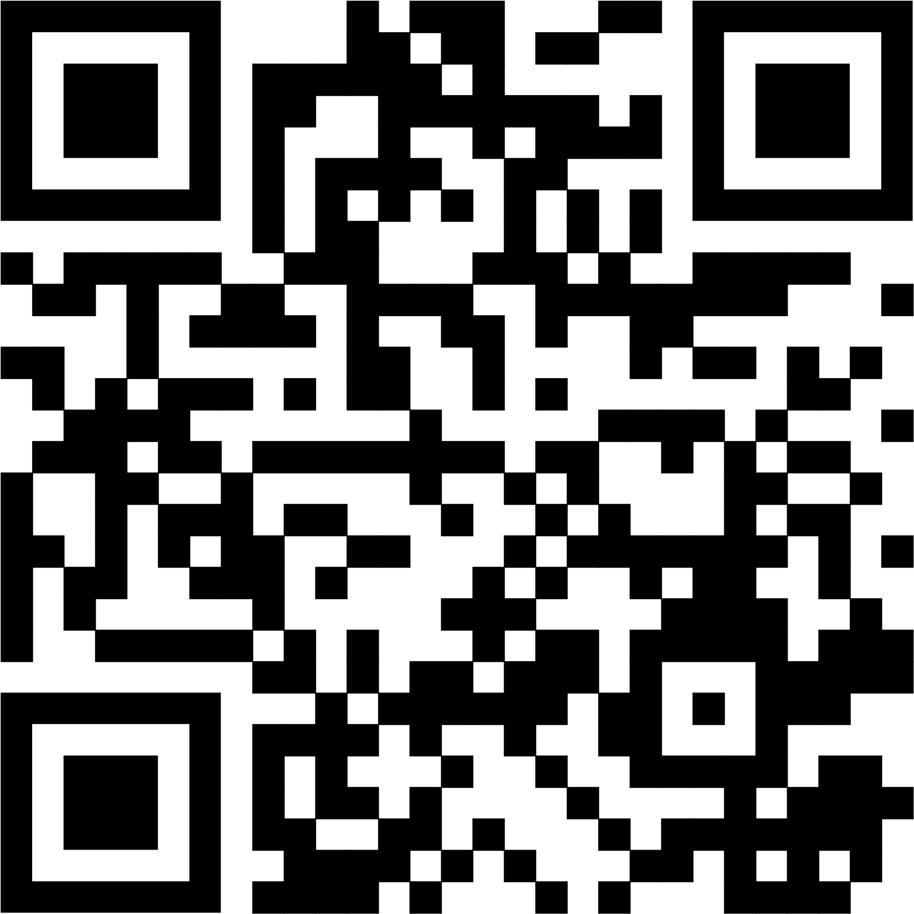
Reader: Heather Robbins
Production & Camera: Kim O’Grady & Grace Jeffers
Interim Director of Music: Ruth Wiwchar
Organist: Dorcas Windsor
Coordinator of Children, Youth & Families: Katie Anderson
Minister: Loraine MacKenzie Shepherd

QR Code for Westworth donations

WSCF-ME’s role is to be a mediator of
peace and understanding.
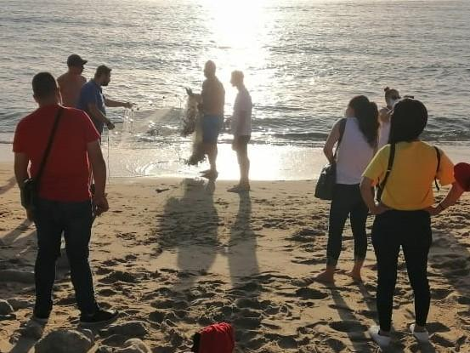
“Cast your nets,” public beach, Sidon, Lebanon
Credit: WSCF-ME
The entanglement of religion and politics in the Middle East often divides communities and leads to conflict, particularly among young people. “We all agreed that it is important to focus on universal values and ethics, reject extremism, and make the necessary efforts to develop practical formulas for fruitful cooperation,” says Rima Bayan Sleem, a 33-year-old judicial assistant from Chouf, Lebanon.
"We all agreed that it is important to focus on universal values and ethics, reject extremism, and make the necessary efforts to develop practical formulas for fruitful cooperation."
Thanks to your Mission & Service gifts, Rima and 36 other young adults gathered in Beirut, Lebanon, for the World Student Christian Federation-Middle East Region (WSCF-ME) 2021. They participated in an Interfaith Dialogue program that develops leaders skilled in preventing violence and fostering peace between communities.
WSCF-ME’s role is to be a mediator of peace and understanding amid all the overwhelming regional issues that include sectarian strife. “The Interfaith Dialogue program’s importance lies in the fact that it brings together youth from different religious backgrounds…to engage in a constructive peace-facilitating dialogue,” says Mira Neaimeh, Regional Executive for WSCF-ME. “I personally believe that change is done in small steps, starting from our regional gatherings that sow seeds of peace to be reaped in the future.”
"The Interfaith Dialogue program’s importance lies in the fact that it brings together youth from different religious backgrounds…to engage in a constructive peace-facilitating dialogue."
Your Mission & Service gifts help leaders in the Middle East and across the world collaborate and promote peaceful dialogue.

