Westworth United Church
1750 Grosvenor Avenue, Winnipeg, Manitoba
on Treaty One Territory in the heart of the Métis Nation

April 30, 2023
4th Sunday of Easter

We Gather to Worship

Welcome

Introit: “The Spring Has Come” Shirley Erena Murray & Colin Gibson

Candle Lighting
“Brother James’ Air” arr. Dale Wood
Treaty Acknowledgement
We are Treaty People!
We live and work,
We worship and play,
On Treaty 1 territory,
The traditional lands of:
The Anishinaabe, Cree, Oji-Cree and Dakota Nations
And the homeland of the Red River Métis Nation.
We receive water from Shoal Lake on Treaty 3 land,
And hydro power from all 5 treaty lands in Manitoba.
We are all Treaty People.

Opening Prayer

Children’s Time

Hymn: VU 158 “Christ Is Alive” TRURO

Prayer of Confession
Forgive us when we don’t make enough time for others.
Forgive us when we can’t hear the voices of family or of friends,
Of community or of strangers
Forgive us when we don’t make space for our own hearts.
Help us find a balance between doing and being,
Between reaching for accomplishments and letting go of results.
Help us know, deep within, that we are each beloved
Just as we are, with no need to prove ourselves.
In the release of our worries and anxieties,
May we find room to receive and give care within our community.

Silent Meditation

Words of Assurance

The Peace of Christ and Interlude:
May the peace of Christ be with you.
And also with you.
“Spring Song” Felix Mendelssohn

We Hear the Word

Psalm 23: VU 748 “God Is My Shepherd” BROTHER JAMES’ AIR

First Scripture Reading: Acts 2:38-47
Hear what the Spirit is saying to the Church.
Thanks be to God.

Gospel Reading: John 10:1-17
This is the Gospel of Christ.
Thanks be to God.

Sung Response: VU 717 “Hallelujah”

Anthem: “Open Thou Mine Eyes” Lancelot Andrewes and John Rutter

Sermon: “We Are Better Together”
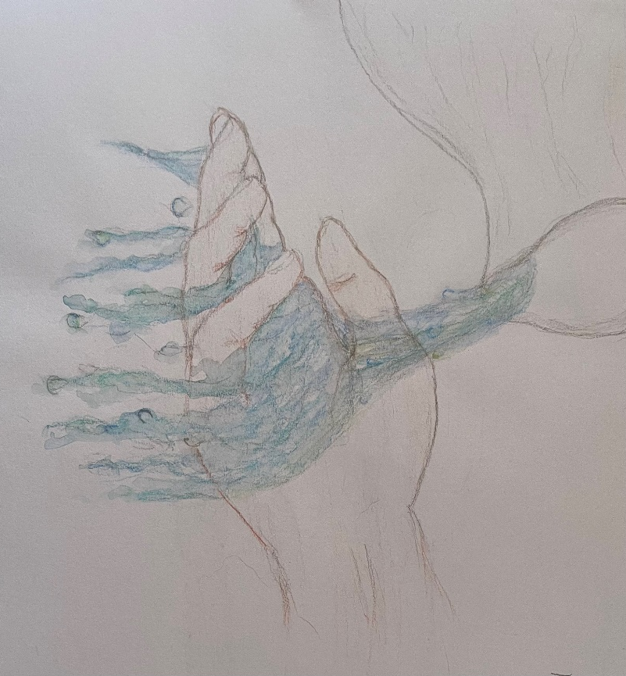
We Respond to the Word

The Sacrament of Baptism and Confirmation

Hymn MV 176 “Three Things I Promise” vs 1-4 BLANN

Offertory Prayer

Ministry of the People

Prayer Introit: VU 400 “Lord Listen to Your Children Praying”

Prayers of the People and Lord’s Prayer

Hymn VU 509 “I, the Lord of Sea and Sky” HERE I AM, LORD

Benediction

Sung Response: VU 974 “Amen” Jim Strathdee

Postlude: “Trumpet Tune in D Major” David N Johnson

Cover Artwork:

Sharon Cadigan
The question: How do I hold it.
The answer: I don’t.
I can not hold God to one certain experience or belief because that seems to change for me as I change so I let my perception of God be fluid.
I feel if I hold too tightly to my expectations or have a rigid vision of who God is and how they show up I may miss the gifts available in any moment.
A fun fact is that our bodies are roughly 60% water. When I visualize God as water it reminds me that God runs through me, sustaining me and all creation. Always connected.

Christine Strike
This faith statement expresses the overlying need for love, community, respect for the earth, and unity amongst it all under the guidance of God.

Reader: Sharon Cadigan
Conductor: Ruth Denton
Organist: Dorcas Windsor
Viola: Vijay Chalasani
Interim Director of Music: Ruth Wiwchar
Coordinator of Children, Youth & Families: Katie Anderson
Minister: Loraine MacKenzie Shepherd
QR Code for Westworth donations
