Westworth United Church
1750 Grosvenor Avenue, Winnipeg, Manitoba
on Treaty One Territory in the heart of the Métis Nation

May 21, 2023
7th Sunday of Easter

We Gather to Worship

Welcome

Candle Lighting
“Morning Has Broken” arr. Chuck Marohnic

Treaty Acknowledgement
We are Treaty People!
We live and work,
We worship and play,
On Treaty 1 territory,
The traditional lands of:
The Anishinaabe, Cree, Oji-Cree and Dakota Nations
And the homeland of the Red River Métis Nation.
We receive water from Shoal Lake on Treaty 3 land,
And hydro power from all 5 treaty lands in Manitoba.
We are all Treaty People.

Opening Prayer: VU 719 “For the Communion of Saints”

Children’s Story

Hymn: VU 356 “Seek Ye First the Kingdom” LAFFERTY

Prayer of Confession
In the growing tide of disillusionment with our world,
God of grace, grant us hope.
As the seconds to midnight decrease with the Doomsday Clock
God of grace, grant us wisdom and courage.
As war and conflict intensify
God of grace, may we be peacemakers.
As climate change threatens our lives with fires and floods,
God of grace, may we have the will to change what we can.

Silent Meditation

Words of Assurance

The Peace of Christ and Interlude:
“Prelude XXII” J.S. Bach
May the peace of Christ be with you.
And also with you.

We Hear the Word

Scripture Reading:
Acts 1:6-14
Hear what the Spirit is saying to the Church.
Thanks be to God.

Sung Response: VU 717 “Hallelujah”

Solo: “Give Me Jesus” arr. Moses Hogan

Sermon: “Doomsday or New Earth?”

We Respond to the Word

Hymn: VU 713 “I See a New Heaven” Carolyn McDade

New Member Litany: Congregational Commitment
Dear friends in Christ,
let us pledge to Heather our support and care.
As your siblings in Christ,
we rejoice in the gifts you bring to us.
We pledge to you our support.
With God’s help, we will together live out
the mission and ministry of Christ’s church.

Offertory Prayer

Ministry of the People

Prayers of the People and Lord’s Prayer VU 921

Hymn: VU 679 “Let There Be Light” TENDERNESS

Benediction

Sung Response: VU 974 “Amen” Jim Strathdee

Postlude: “Praise His Greatness” arr. Mark Hayes

Reader: Ruth Wiwchar QR Code for Westworth donations
Production & Camera:
Organist: Dorcas Windsor
Soloist & Interim Director of Music: Ruth Wiwchar
Coordinator of Children, Youth & Families: Katie Anderson
Minister: Loraine MacKenzie Shepherd

You are invited to remain in the sanctuary and listen to the postlude. If you are inspired to do so, please speak to the organist with a message of thanks.

Countering increasing violence and misinformation
Credit: The United Church of Canada/CHURCHx
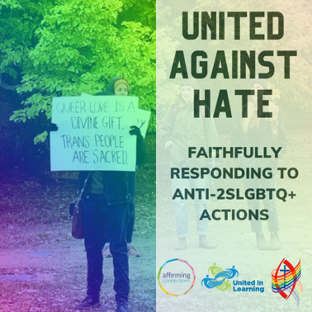
On February 15, 2023, Mission & Service partners United in Learning, Affirming Connections, and Affirm United/S’Affirmer Ensemble colla-borated to host a webinar called United against Hate.
There is an alarming increase in violence and misinformation targeted against transgender folks and drag artists. The United against Hate webinar provided context to allies who may not have known the depth of the challenges faced by the Two Spirit or LGBTQIA+ community and shared ideas on how best to support community events that regularly face protests and barriers. Panellists also offered insight into building a safe and educational social media presence, including managing challenging discussion topics.
The webinar was an overwhelming success, with the live limit of 100 participants reached. Those who could not attend were encouraged to watch the recording. Participants shared positive feedback and made action plans on how to move forward together.
Your gifts to Mission & Service help support future events that will enable Affirming communities of faith to truly live into that identity in practical and safe ways.

