Westworth United Church
1750 Grosvenor Avenue, Winnipeg, Manitoba
on Treaty One Territory in the heart of the Métis Nation

June 18th, 2023
The Spirituality of Canoeing

We Gather to Worship

Pre-Service Video of Canoeing

Welcome & Announcements

Candle Lighting

Video: “Canoe Song” Connie Kaldor; video Nancy Pinnell

Treaty Acknowledgement
We are Treaty People!
We live and work,
We worship and play,
On Treaty 1 territory,
The traditional lands of:
The Anishinaabe, Cree, Oji-Cree and Dakota Nations
and the homeland of the Red River Métis Nation.
We receive water from Shoal Lake on Treaty 3 land,
And hydro power from all 5 treaty lands in Manitoba.
We are all Treaty People.

Opening Prayer: VU 645 “Living Water, Source of Life”

Hymn: VU 388 “Spirit Dancing” Farquharson/Erhardt

A Prayer for the Care of Creation: VU 311

Silent Meditation

Words of Assurance

The Peace of Christ and Interlude
“All Things Bright and Beautiful” arr. Penny Rodriguez
May the peace of Christ be with you.
And also with you.

We Hear the Word

First Scripture Reading:
Job 12:7-10
This is testimony to the Word.
Thanks be to God.

Responsive Reading: VU 826 “Psalm 104” Parts 1 & 2; Refrain 2

Solo: “Morning Has Broken” Eleanor Farjeon & Yusuf Islam

Sermon: “The Spirituality of Canoeing”

We Respond to the Word

Hymn: VU 297 “All Praise to You” FINLANDIA

A Minute for the Environment

Offertory Prayer
There is an offering box attached to the back wall into which you may place your offering. As well, there is a QR code below, which will take you to the secure donation button on Westworth’s website. We are grateful for gifts of time, talent and treasure.

Video: “Land of the Silver Birch” arr. Fred Penner; video Nancy Pinnell

Prayer’s of the People and Lord’s Prayer
Prayer Introit: VU 865 “Hear Our Prayer”

Hymn: MV 30 “It’s a Song of Praise to the Maker” Duck/Klusmeier

Benediction

Sung Response: VU 963 “May the Grace of Christ Attend Us”
Jeeva Sam & Fred K. Graham

Postlude: “I’ve Got Peace Like a River” arr. Mark Hayes

Reader: Heather Robbins
Soloist: Martin Robson
A Minute for the Environment: Frank Wynes
Organist: Dorcas Windsor
Interim Director of Music: Ruth Wiwchar
Coordinator of Children, Youth & Families: Katie Anderson Westworth Donations
Minister: Loraine MacKenzie Shepherd

You are invited to remain in the sanctuary and listen to the postlude. If you are inspired to do so, please speak to the organist with a message of thanks.

Fewer than 600 people can still speak Inuinnaqtun fluently.
Credit: Pitquhirnikkut Ilihautiniq/Kitikmeot Heritage Society
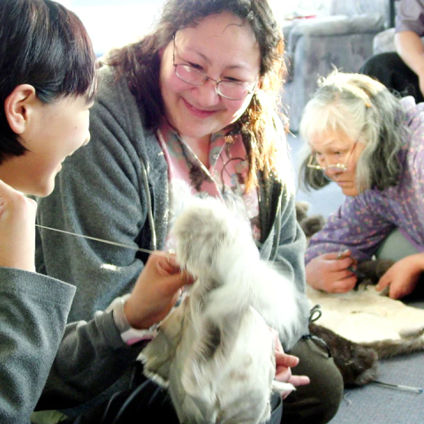
These days, most of us have access to technology that allows us to learn the world’s common languages. But countless languages—including many Indigenous languages—can only be learned from their few remaining speakers.
Revitalizing a lost language, as one of our partners in Nunavut is doing, is an important way to preserve not just the language but also the culture that surrounds it.
The Inuinnaqtun language is the cultural foundation of the Inuinnait people, who live in the central Canadian Arctic. The literal meaning of the word Inuinnaqtun is “to be like an Inuinnaq (a person).” Today, fewer than 600 people can still speak Inuinnaqtun fluently. Many lost the language when they were removed from their communities and sent to residential schools.
Pitquhirnikkut Ilihautiniq/Kitikmeot Heritage Society in Cambridge Bay, Nunavut, is working hard to keep Inuinnaqtun alive. One-on-one language immersion sessions with mentors inspire reconnection. Through everyday conversations at home and on the land, mentorship is helping to heal the wounds of systemic oppression.
In partnership with Mission & Service, Inuinnaqtun language mentors get resources to allow them to spend 300 hours a year working with their apprentices to begin to restore the language.
Your gifts to Mission & Service help partners continue to restore language and culture. Thank you.

