Westworth United Church
1750 Grosvenor Avenue, Winnipeg, Manitoba
on Treaty One Territory in the heart of the Métis Nation

June 25th, 2023
De-Covenanting Service

We Gather to Worship

Welcome & Announcements

Candle Lighting & Music
“Celtic Melody” G. O’Connor Morris

Treaty Acknowledgement
We are Treaty People!
We live and work,
We worship and play,
On Treaty 1 territory,
The traditional lands of:
The Anishinaabe, Cree, Oji-Cree and Dakota Nations
and the homeland of the Red River Métis Nation.
We receive water from Shoal Lake on Treaty 3 land,
And hydro power from all 5 treaty lands in Manitoba.
We are all Treaty People.

Opening Prayer

Hymn: MV 135 “Called by Earth and Sky” Pat Mayberry

Prayer of Confession
With mixed emotions, we worship today.
Help us to release relationships and commitments
so that we can find closure and make space
for new relationships and commitments.
Help us to give thanks for past successes
And release past disappointments.
With your grace, lead us all into future possibilities.

Silent Meditation

Words of Assurance

The Peace of Christ and Interlude
“This is the Day of New Beginnings” Carlton R. Young arr. Mark Hayes May the peace of Christ be with you.
And also with you.

We Hear the Word

Scripture Reading:
Romans 8:26-30, 38-39
Hear what the Spirit is saying to the Church.
Thanks be to God.

Psalm in Song: VU 820 “Psalm 100” Linnea Good

Duet: “The Gift of Love” American folk tune arr. Hal Hopson

Sermon: “Endings and Beginnings”

We Respond to the Word

Hymn: VU 569 “You Call Us Out” THORNBURY

Offertory Prayer
There is an offering box attached to the back wall into which you may place your offering. As well, there is a QR code below, which will take you to the secure donation button on Westworth’s website. We are grateful for gifts of time, talent and treasure.

A Liturgy of De-Covenanting (see insert for De-Covenanting)

Musical Meditation MV 85 “Take, O Take Me as I Am” Bell/Maule

The Sacrament of Holy Communion (see insert for Earth Communion)

Hymn VU 884 “You Shall Go Out in Joy” TREES OF THE FIELD

Benediction

Sung Benediciton: VU 963 “May the Grace of Christ Attend Us”
Jeeva Sam & Fred K. Graham

Postlude: “Prelude in Classic Style” Gordon Young

Reader: Denise Jones
Duet: George and Bettina Nyman
Communion Servers: Phio White, William Lougheed, Ava Younka,
Bruce Tefft, Teresa Sztaba
Organist: Dorcas Windsor
Interim Director of Music: Ruth Wiwchar
Coordinator of Children, Youth & Families: Katie Anderson
Minister: Loraine MacKenzie Shepherd Westworth Donations

You are invited to remain in the sanctuary and listen to the postlude. If you are inspired to do so, please speak to the organist with a message of thanks.

Minute for Mission
“We have power. It’s the society at large that assumes we don’t take part; often we’re behind the scenes.”

Credit: Amy Zavitz/The United Church of Canada
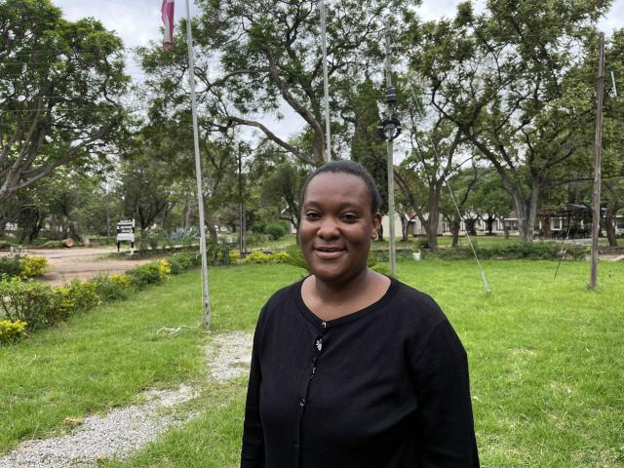
Eunice Chianka felt a calling to preach and share the gift of education. Growing up, most of the religious leaders she knew were male ministers. When she had the opportunity to encounter female ministers, she felt inspired, and knew she wanted to inspire and empower other young girls in the same way.
“I always ask God: Do you really love us as women? I need to do my best as a woman to challenge the dominance of men,” Eunice says.
Coming from the United Methodist Church, Eunice is one of the students who received a scholarship from the United Church of Canada’s partnership with the United Theological Seminary in Zimbabwe. She shared that she wanted to “express her humble gratitude for this opportunity.”
When it comes to inspiring young women, Eunice shares a few words: “If I can do it, they can do the same,” she explains. “We have power. It’s the society at large that assumes we don’t take part, often we’re behind the scenes.”
The strength and determination of leaders such as Eunice inspires us all. Your Mission and Service gifts empower young women like Eunice as they grow to become leaders for the future. Thank you.

