Westworth United Church
1750 Grosvenor Avenue, Winnipeg, Manitoba
on Treaty One Territory in the heart of the Métis Nation

August 6, 2023

We Gather to Worship

Welcome & Announcements

Candle Lighting
“When Morning Gilds the Skies” arr. John Carter

Treaty Acknowledgement

Call to Worship
Open our stories to any chapter:
A friend will have a page there.
Look closely at our vigorous roots:
Companions nourished what holds us.
Ask about our migrations, our paths:
Strangers became neighbours became loved ones.
Listen to the cadence of our song:
A symphony of lives soars through each note.
Watch us shelter beneath soft wings:
Friendship gentles our weariness.
Discover our tables set with bread and laughter:
For we share what we receive.
Sift the sands of daily journey:
The grains of God’s kinship glimmer everywhere.

Hymn: MV 122 “This is the Day” Bruce Harding

Prayer of Confession
Sometimes, God,
We are forced to make choices
That take us into the unknown.
These choices challenge our relationships,
Our place in the world,
Our comfort.
These choices call us to make a journey
We never imagined,
And cause us to doubt.
When we react out of confusion,
Discomfort and doubt,
Be with us.
When our words and actions are hurtful,
Remind us that we are not alone in this world.
Remind us that we are loved and supported
Not only by You, but by all who love us.
May this support be a core of courage,
Giving us the confidence to enter into the unknown.

Silent Meditation

Words of Assurance

Passing the Peace of Christ
May the peace of Christ be with you.
And also with you.

“This is the Day of New Beginnings” Carlton R. Young arr. Mark Hayes

We Hear the Word

Conversation for All Ages

Hymn: VU 241 “Oh, Sing to Our God” CANTAD AL SEŇOR

Scripture Reading:
Ruth 1:1-22
Thanks be to God who gives us the Word.
Thanks be to God.

Sung Response: MV 50 “Alleluia” arr. Norah Duncan IV

Musical Offering: “You Raise Me Up” Rolf Løvland

Sermon

We Respond to the Word

Hymn: MV 216 “Wherever You May Go” MIT FREUDEN ZART

Offertory Prayer

Prayer Introit: MV 75 “Holy Spirit Come to Us” arr. Jacques Berthier

Prayers of the People

Hymn: VU 333 “Love Divine, All Loves Excelling” HYFRYDOL

Benediction

Sung Response: VU 974 “Amen” Jim Strathdee

Postlude: “Hyfrydol” Healey Willan

Reader: Bernard Boland
Organist: Dorcas Windsor
Flute: Bettina Nyman
Interim Director of Music: Ruth Wiwchar
Coordinator of Children, Youth & Families: Katie Anderson
Minister: Tricia Gerhard Westworth Donations

Minute for Mission
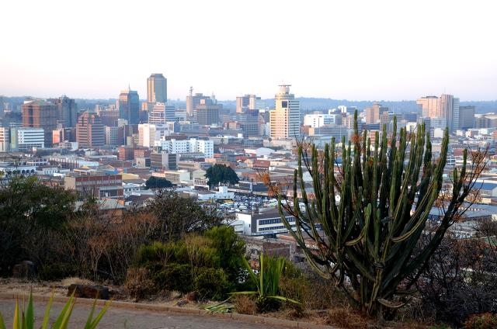
Thank you for helping to give youth the space to learn and grow.

Harare, Zimbabwe, where the Zimbabwe Council of Churches’ office is located.
Credit: Image by toubibe from Pixabay
The Zimbabwe Council of Churches will be hosting an annual three-day youth leadership development program in 2023.
In partnership with Mission and Service, the program will host 50 youth from 10 provinces to increase young people’s knowledge and skills as active citizens. Through involvement and education around policy reforms, electoral and budgetary processes, natural resource governance, and peace-building, youth will gain skills in nation-building processes.
The young people will take their skills and experiences from the program to their churches and communities. They will have the knowledge and resources to create their own plans of action, and opportunities to regularly meet or check in with other attendees.
The Zimbabwe Council of Churches will continue to engage young people in all of its programming to ensure the voices of youth are represented and heard.
Your gifts to Mission and Service help develop and continue programs where young people can flourish. Thank you for helping to give youth the space to learn and grow.

