Westworth United Church
1750 Grosvenor Avenue, Winnipeg, Manitoba
on Treaty One Territory in the heart of the Métis Nation

August 13, 2023

We Gather to Worship

Welcome & Announcements

Candle Lighting
“Gather Us In” Marty Haugen arr. Mark Hayes

Treaty Acknowledgement

Call to Worship
As a worker gathers their tools
Left Side: As a poet gathers her images
Right Side: As a musician gathers his band,
St. Andrews: As a scholar gathers her arguments
Westworth: As a writer gathers their stories
All: As a preacher gathers the texts
So the Divine gathers the people,
Joining them together for prayer and community.
As we gather now,
Let us worship with joy and passion.
Amen.

Hymn: VU 389 “God is Here” BLAENWERN

Prayer of Confession
Holy Presence,
We are not perfect.
We know we make mistakes,
We hurt others,
We think too highly of ourselves,
And we take ourselves far too seriously.
We wound those we love
And cut out those who we do not care to know.
We expect too much of others
And not enough of ourselves.
And yet we dream of a time when we will be kind and gentle,
Wise and considerate,
Open-minded and welcoming.
Hear our prayers of confession today, Holy One,
And lead us down a humble path
That we may serve you and our neighbour
In your Spirit.

Silent Meditation

Words of Assurance

Passing the Peace of Christ
May the peace of Christ be with you.
And also with you.

“Come, O Fount of Every Blessing” arr. John Carter

We Hear the Word

Conversation for All Ages

Hymn: VU 230 “Heaven is Singing for Joy” HEAVEN IS SINGING

Scripture Reading:
Ruth 2:1-23
Thanks be to God who gives us the Word.
Thanks be to God.

Sung Response: MV 50 “Alleluia” arr. Norah Duncan IV

Musical Offering: “Here I Am, Lord” Daniel L. Schutte arr. Craig Courtney

Sermon

We Respond to the Word

Hymn: VU 278 “In the Quiet Curve of the Evening” YOU ARE THERE

Offertory Prayer

Prayer Introit: VU 400 “Lord, Listen to Your Children Praying”

Prayers of the People

Hymn: VU 578 “A Fire is Meant for Burning” JOYOUS LIGHT

Benediction

Sung Response: VU 974 “Amen” Jim Strathdee

Postlude: “Masque” Denis Bédard

Reader: Vinny Ashton
Soloist: Keely McPeek
Organist: Dorcas Windsor
Interim Director of Music: Ruth Wiwchar
Coordinator of Children, Youth & Families: Katie Anderson
Minister: Tricia Gerhard Westworth Donations
Minute for Mission
“I met so many different people from different cultures and regions, and got to learn their journeys in faith.”
Credit: Cave Springs Camp
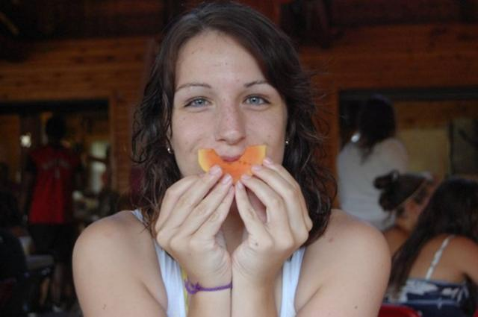
Lindsay Vautour, the United Church’s Engagement and Stewardship Associate, started attending a United Church camp at the tender age of five. There, she not only met lifelong friends and gained job skills as a counsellor, but it also helped chart her course to eventually work for The United Church of Canada.
“Coming from a financially tight background, I’m extremely grateful for the assistance available that let my brother and me attend camp every summer. I met so many different people from different cultures and regions, and got to learn their journeys in faith. I still keep in contact with some camp friends over 20 years later,” she says.
“One of my most prominent memories was with a fellow 13-year-old camper who told me that she loved camp because she could be herself without any expectations. She said, ‘I’m not the weird kid or the foster kid here, I’m just me,’” she recounts. “That’s something I resonate with because I wasn’t particularly popular in school, but popularity never mattered at camp, and it’s beautiful to know that that’s a widely shared perception.”
Children come together at United Church camps across Canada to learn the gospel in a safe and supportive environment. Through campfire stories, hiking, music, canoeing, and so much more, campers gain confidence while enjoying unique activities and exploring their curiosity. At camp kids learn soft skills like self-confidence, patience, and organization as well as hard skills in sports, crafting, and music.
Without the generosity of supporters, children who attend camp wouldn’t be able to continue having such affirming and defining experiences. Your gifts through Mission and Service are deeply appreciated.

