Westworth United Church
1750 Grosvenor Avenue, Winnipeg, Manitoba
on Treaty One Territory in the heart of the Métis Nation

August 27, 2023
St. Andrew’s River Heights & Westworth United Churches

We Gather to Worship

Welcome & Announcements

Candle Lighting
“Be Still My Soul” Jean Sibelius arr. Greg Howlett

Treaty Acknowledgement

Call to Worship
Surely God is in this place!
We have come to thank God
For the summer beauty of lake, prairie and forest.
Surely God is in this place!
We have come to thank God for all the joy that is our
In friendship and in family.
Surely God is in this place!
We have come to thank God for our churches
And the fellowship we find in our faith communities.
Surely God is in this place!
We have come to thank God
For God’s promised presence with us,
In time and beyond time.
We have come to worship God,
For surely God is in this place!

Opening Prayer

Hymn: MV 18 “Lord, Prepare Me to Be a Sanctuary”
John W. Thompson & Randy Scruggs

Prayer of Confession
Forgive us, O God,
When something we have done or left undone,
Said or left unsaid,
Causes harm or hurt to another.
Forgive our carelessness with our words
And our inattention to our actions.
Have mercy on us when we blame others
Instead of taking responsibility for our own actions.
Give us your grace when we do not stand up
And speak out for those who have no voice.
Help us to become thoughtful, loving people,
Intent on living the way you have called us to live
And serving the way you have called us to serve.

Silent Meditation

Words of Assurance

Passing the Peace of Christ
May the peace of Christ be with you.
And also with you.
“Radiant” David Ritter

We Hear the Word

Conversation for All Ages

Hymn: MV 92 “Like a Rock” Keri K. Wehlander & Linnea Good

Scripture Reading:
Ruth 4:1-17
Thanks be to God who gives us the Word.
Thanks be to God.

Sung Response: MV 50 “Alleluia” arr. Norah Duncan IV

Musical Offering: “Shall We Gather at the River” Robert Lowry

Sermon

We Respond to the Word

Hymn: MV 26 “Your Love is Amazing” Brenton Brown & Brian Doerkson

Offertory Prayer

Prayers of the People

Hymn: VU 333 “Loves Divine, All Loves Excelling” HYFRYDOL

Benediction

Sung Response: VU 974 “Amen” Jim Strathdee

Postlude: “Irish Blessing” TRADITIONAL

Reader: Clark Brownlee
Organist: Megan Dufrat
Soloist: Martin Robson
Interim Director of Music: Ruth Wiwchar
Coordinator of Children, Youth & Families: Katie Anderson
Minister: Tricia Gerhard Westworth Donations
Mission and Service Stories
“They opened the gate for me; I have no words.”
Credit: Provided by Almaz Fesshaye
When Almaz Fesshaye and her two young children arrived in Canada in 1991, they did not know what to expect. None of them knew the language or culture but hoped and prayed that Canada would be a safer place than Eritrea, a war-torn country in Eastern Africa.
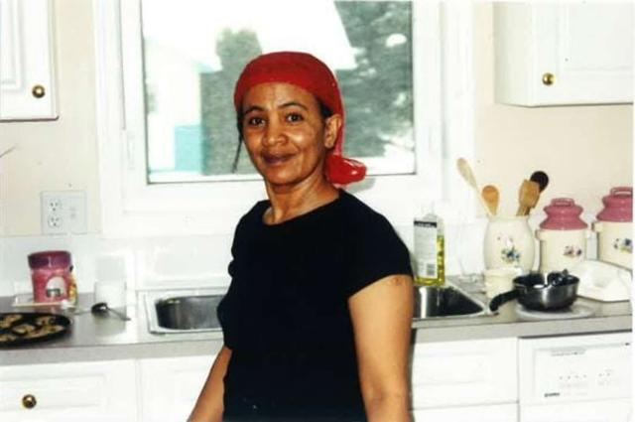
Leaving Eritrea could have meant the difference between life and death. “Everyone had to be a soldier,” Almaz describes, before sharing the sombre note that “people have died trying to escape.” She was devastated to have to flee her home and frightened by not knowing what would come next.
When Almaz and her two children—then aged four and six—arrived in Alberta, they were greeted with warmth and love by members of Gaetz Memorial United Church. “They opened the gate for me; I have no words,” she says with gratitude. “They changed my life, starting from getting furniture, renting a place to live, helping me with the language, and support for my kids.”
Almaz describes the congregation and community as “selfless and kind.” The church was one block from the family’s new home, and Almaz says, “My son was very forgetful, so I gave the church secretary an extra key.”
Now settled in Red Deer, Alberta, Almaz is joyfully giving back to her community. She works in social services and offers her time as a volunteer with local programs that help people experiencing homelessness and poverty. She is also passionate about helping other refugees learn the local culture and language.
Your gifts to Mission and Service help support life-changing programming and staffing to support families seeking safety.
Almaz has some words for anyone considering supporting refugee programs through Mission and Service: “Don’t think twice! It doesn’t have to be millions—whatever you give means a lot. If it is financial, educational, time, knowledge, it means a lot. You are saving the lives of human beings and making the world better.” Thank you for your generosity.

