Westworth United Church
1750 Grosvenor Avenue, Winnipeg, Manitoba
on Treaty One Territory in the heart of the Red River Métis Nation

September 24, 2023
Truth and Reconciliation

We Gather to Worship

Welcome

Treaty Acknowledgement

Lighting the Candles
No. 2 from Six Interludes for Organ Denis Bédard

Call to Worship

Opening Prayer
Creator,
We give thanks for the knowledge you give to us through all the traditions of the world. Help us to honor the gifts that each tradition offers.
We seek to take the path of love
We give thanks for the east, for the sun that rises to begin each new day. We give thanks for new life, for youth. We give thanks for new learning and new experiences.
We seek to take the path of love.
We give thanks for the south, for the growth of the summertime in our lives, for the teachings to be kind to ourselves and others. Help us, who are elders, love and respect children and youth. Help us to care for the elderly and those who cannot care for themselves.
We seek to take the path of love.
We give thanks for the west, for the understanding of how to care for the earth. Creator, help us to use this understanding to bring joy and new life to the world.
We seek to take the path of love.
We give thanks for the north. Help us to receive gifts of wisdom and new perspectives from all peoples. Help us to grow our roots of compassion deeper as we journey.
Together we will take the path of love for ourselves and for each other. Amen.

Hymn MV 135 Called By Earth And Sky

The Peace of Christ and Interlude
Reflection David Ritter

May the peace of Christ be with you.
And also with you.

We Hear the Word

Sharing the Story

Hymn MV 145 Draw the Circle Wide

Scripture 1 Kings 3: 5-12
Matthew 19: 16-22

Special Music Now Let Us All Praise God and Sing Gordon Young

Reflection

Hymn MV 154 Deep in Our Hearts

Offering Prayer

We Respond to the Word

Prayers of the People

Hymn VU 633 Bless Now, O God, the Journey

Benediction
The Beatitudes W. H. Anderson

Sung Response VU 974 Amen

Postlude Traumerei, Op. 15 No. 7 Robert Schumann

Reader: Denise Jones
Organist: Megan Dufrat
Soloist: Dariyan Dubik, Evan Glazier, Sloan Smith
Director of Music: Valdine Anderson
Coordinator of Children, Youth & Families: Katie Anderson
Minister: Tricia Gerhard
QR Code for Westworth Donations
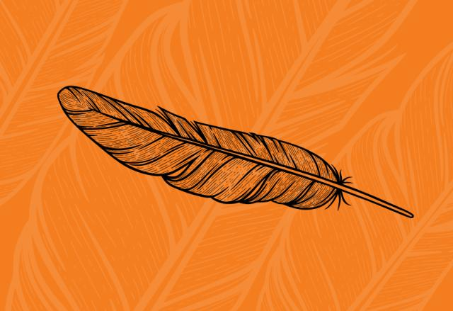

Mission and Service Stories
“You bring a gift that I don’t have; I bring a gift that you may not have.”
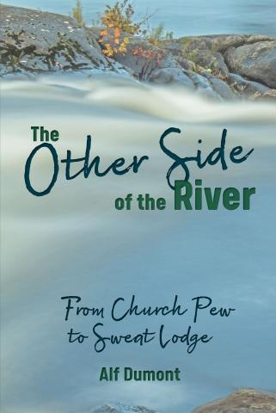
Alf Dumont’s memoir bridges First Nations and non‒First Nations understandings.

When Alf Dumont’s Roman Catholic father and Anishinaabe mother asked the priest serving the Shawanaga reserve to marry them, the priest rejected their request, advising them to “marry someone of their own kind.” Nearby, a United Church minister had a different response. He told the couple he had just two rules: “If you have differences, talk them out and just try to get along.”
“Dad and Mom said ‘I think we can do that.’ They brought together First Nations understanding and non-First Nations understanding. That’s how I came to the church,” Dumont recounts in a United in Learning webinar.
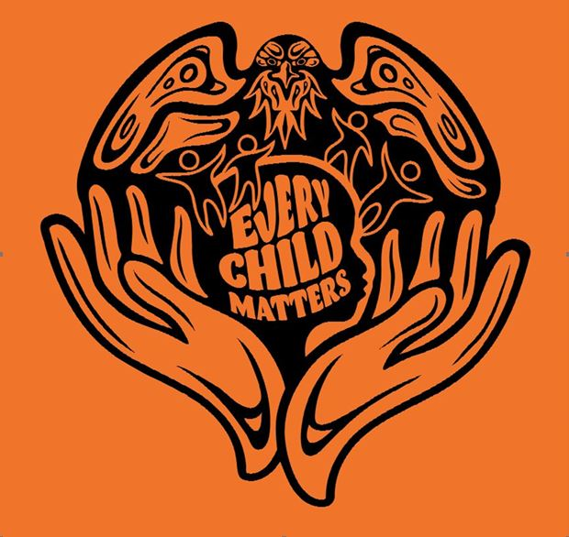
Dumont spent his life as a spiritual leader, serving the United Church as a minister while staying connected with his traditional Indigenous spirituality. His memoir The Other Side of the River: From Church Pew to Sweat Lodge shares stories of how Dumont walks between the two worlds of Indigenous and settler, traditional spirituality and Christianity.
“Part of the struggle with me in life was to find out who I was as Anishinaabe and who I was as French, Irish, and English mix,” Dumont shares. With a foot in both sides of the river, Dumont’s words eloquently draw together spiritual threads.
“There are seven truths in some of the Anishinaabe teaching: love, courage, respect, humility, truth, wisdom, and honesty. But you can’t have one of those teachings or truths without having the others. So you can’t have respect without love. You can’t have truth without humility,” explains Dumont. “I took those underlying teachings and applied them to the four teachings on love: Love God. Love your neighbour. Love your enemy. Love yourself. You can’t have one teaching without the other. You can’t love God if you don’t truly love yourself. You cannot love your neighbour unless you truly love God.”
In an interview, Broadview magazine asked Dumont to weigh in on the future of reconciliation: “Part of the struggle has to do with learning to walk together again. It means being as open as we can,” he says. “You bring a gift that I don’t have; I bring a gift that you may not have. And as we share, we learn from the gifts that we have been given.”
Your gifts through Mission and Service help support the creation and publication of luminous, timely work like Dumont’s book as well as the webinar discussions and education events that follow. Through listening and learning, we take important steps forward on the journey toward reconciliation.

