Westworth United Church
1750 Grosvenor Avenue, Winnipeg, Manitoba
on Treaty One Territory in the heart of the Métis Nation

October 8, 2023
Thanksgiving Sunday

We Gather to Worship

Welcome

Introit This is the Day

Candle Lighting
Wer nur den Lieben Gott Lässt Walten, Versus 1 Georg Böhm

Treaty Acknowledgement

Call to worship
In the songs of birds
And the warmth of sunshine,
We welcome the presence of God.
In fields of grain, growing gardens,
And flowers blooming,
We welcome the presence of God.
in the wave of a neighbour
and the phone call of a friend
we welcome the presence of God.
In the bustle of the day,
And the quiet of the evening,
We welcome the presence of God.
In the work we do
And the games we play,
We welcome the presence of God.
In the memories we hold
And the love we have known,
We welcome the presence of God.
Come, let us worship in the presence of God.

Opening Prayer

Hymn VU 218 We Praise You, O God

The Peace of Christ and Interlude
May the peace of Christ be with you.
And also with you

For the Beauty of the Earth arr. Phillip Keveren

Anthem For the Beauty of the Earth

Sharing the Story And Bear Says Thanks

Act of Thanksgiving

Hymn VU 227 For the Fruit of All Creation

We Hear the Word

Scripture Reading: Deuteronomy 8: 7-18
Hear what the Spirit is saying to the Church.
Thanks be to God.

Gospel Reading: Luke 17: 11-19
This is the Gospel of Christ.
Thanks be to God.

Sung Response VU 717 Hallelujah

Anthem With a Voice of Singing

Sermon

We Respond to the Word

Hymn VU 236 Now Thank We All Our God

Offertory Prayer

Prayers of the People & The Lord’s Prayer VU 921

Hymn VU 520 We Plough the Fields and Scatter

Benediction

Sung Response VU 974 Amen

Postlude All Creatures of our God and King arr. Phillip Keveren
Reader: Earl Gould
Organist: Megan Dufrat
Director of Music: Valdine Anderson
Coordinator of Children, Youth & Families: Katie Anderson
Minister: Tricia Gerhard

QR Code for Westworth Donations

Your generous support of Mission and Service
provides life-saving advocacy.
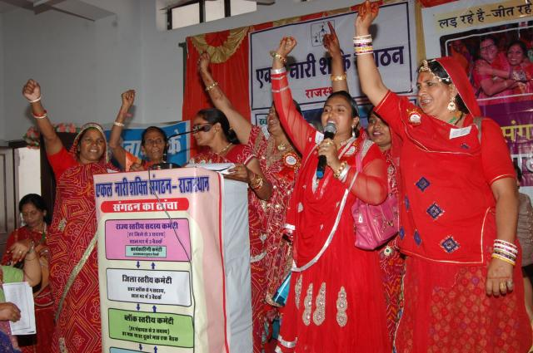
Credit: Astha Sansthan's Association of Strong Women Alone
When Geeta’s husband died, she not only lost her life partner but also her home. Because she was no longer married her in-laws wouldn’t allow her to stay in their multi-generational residence.
Geeta is just one of an estimated 72 million women in India who are not married—nearly double the entire population of Canada. In India, most women are expected to marry and live with their husband and his family. Unmarried women, even those who are widowed, are often seen as dishonourable. Like Geeta, they may suffer abuse.
Fortunately, Geeta was able to flee to her parents’ home with her two younger children, but many parents will not allow their newly single daughters to return.
While Geeta and her younger children stayed with her parents, her in-laws stole her jewellery, changed the locks, and kept her two older children from her. That’s when she turned to Mission and Service partner Astha Sansthan’s Association of Strong Women Alone (ASWA) for help.
ASWA supports thousands of single women from low-income backgrounds in Rajasthan to defend their rights. The organization has also shared their advocacy methods and experiences with other groups across India.
Thanks to ASWA’s help, Geeta’s in-laws ultimately had to give back her jewellery, unlock her home, and return her older children to her care.
Today, Geeta is living peacefully with her children in her part of the house.
Your generous support of Mission and Service provides life-saving advocacy. It is one way your gifts address crushing inequality and help build a better world for all. Thank you!

