Westworth United Church
1750 Grosvenor Avenue, Winnipeg, Manitoba
on Treaty One Territory in the heart of the Métis Nation

October 15, 2023
Food is Sacred

We Gather to Worship

Welcome

Introit This is the Day Lawson

Candle Lighting
How Great Thou Art arr. Serban Nichifor

Treaty Acknowledgement

Hymn MV 61 I Praise You, O God

Introduction

Call to worship
Taken from the earth…
Like lumps of clay.
Made from the soil…
Like lumps of clay.
Moulded and fashioned…
Like lumps of clay.
Worked and re-worked…
Like lumps of clay.
People of God, look around you!
Look and see what God has made—
Creations of beauty.
The birds of the air,
The fish of the sea…
Creations of joy!
Every star, every planet,
Every atom, every quark…
Creations of love!
As part of this love-given, joy filled,
Beautiful creation,
Let us give thanks to the Potter
Who gave us life and form –
Alleluia! Alleluia! Alleluia!

Opening Prayer

Hymn MV 70 It’s a Song of Praise to the Maker

The Peace of Christ and Interlude
May the peace of Christ be with you.
And also with you
Meditate David Ritter

Sharing the Story

Hymn MV 174 Soil of God, You and I

We Hear the Word

Scripture Reading: Genesis 2: 5-9
Hear what the Spirit is saying to the Church.
Thanks be to God.

Psalm 65 VU 783

Gospel Reading: Mark 4: 1-9
This is the Gospel of Christ.
Thanks be to God.

Sung Response VU 717 Hallelujah

Anthem Here I am Lord Schutte, arr. Courtney

Sermon

We Respond to the Word

Hymn VU 307 Touch the Earth Lightly

Offertory Prayer

Prayers of the People & The Lord’s Prayer VU 921

Hymn VU 308 Many and Great, O God, Are Your Works

Benediction

Sung Response VU 974 Amen

Postlude Praise to the Lord, the Almighty arr. Phillip Keveren
Women for Change strives to improve conditions in rural communities by empowering women and girls.
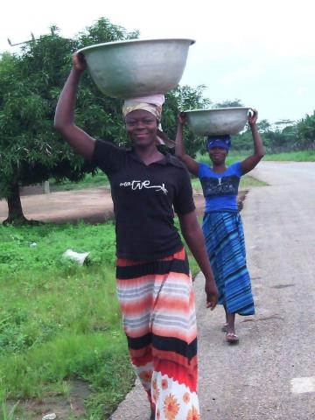
Credit: Women for Change, Zambia
Published On: September 15, 2023
In areas where historically there has been little rain, now there are floods, and where there were floods, now there are droughts. That’s how Shadrick Chembe, the Monitoring and Evaluation Manager at Women for Change—an organization in Zambia that strives to improve conditions in rural communities by empowering women and girls—describes the changing climate in Zambia. Women bear the brunt.
“In Zambia, women are still responsible for collecting firewood and charcoal and making food. Now, because of climate change, they have to walk a longer distance to gather firewood. Charcoal is harder to get. That means it’s harder to make food. At the same time, women aren’t involved in the decision-making processes that impact this work,” explains Chembe.
Women for Change was established in 1992, and its long-standing partnership with the United Church stretches back to1995. From the beginning, mobilizing communities to share ideas and best practices has been key to the work. Since its inception, 1,500 community groups have been established, with 25‒40 people in each group and representatives from each forming associations. The groups discuss a variety of justice-related topics. Building climate resiliency by preparing for, recovering from and adapting to drastically changing weather patterns is a priority.
Weather extremes due to climate change coupled with companies promoting seeds that only produce a single crop increasingly put people at risk.
“The majority of farmers are poor. They can’t buy seeds, but companies have created seeds that force farmers to have to purchase them each year,” says Chembe. “Groups discuss how they can save and share seeds, what they can plant with longer or shorter rains, and if there are traditional methods that can increase food production,” he says, adding, “We are grateful for the United Church’s support. The church has really been there for many years, helping us build awareness and resiliency. It’s been a real partnership.”
Your gifts through Mission and Service support long-term, life-changing work through committed partners like Women for Change. Thank you.

