Westworth United Church
1750 Grosvenor Avenue, Winnipeg, Manitoba
on Treaty One Territory in the heart of the Red River Métis Nation

October 29, 2023
22nd Week After Pentecost

We Gather to Worship

Welcome

Introit Organ Prelude no 3 Denis Bédard

Treaty Acknowledgement

Lighting the Candles There is a Balm in Gilead arr. Keveren

Call to Worship

Opening Prayer

Hymn VU 612 There is a Balm in Gilead

The Peace of Christ and Interlude:
May the peace of Christ be with you.
And also with you.
Vision David Ritter

Sharing the Story

Hymn VU 574 Come Let us Sing of a Wonderful Love

We Hear the Word

Scripture Reading Deuteronomy 34: 1-12
Hear what the Spirit is saying to the Church.
Thanks be to God.

Gospel Reading Matthew 22: 34-46
This is the Gospel of Christ.
Thanks be to God

Anthem Ancient Words Craig Courtney

Reflection Have You Seen the Promised Land?

We Respond to the Word

Hymn VU 232 Joyful, Joyful We Adore You

Offering

Offertory Prayer

Prayers of the People

Hymn MV 212 Sent Out in Jesus Name

Benediction

Sung Response VU 974 Amen

Postlude Joy Song arr. Mark Hayes

Reader: Denise Jones QR Code for Westworth Donations
Organist: Megan Dufrat
Director of Music: Valdine Anderson
Coordinator of Children, Youth & Families: Katie Anderson
Minister: Ray Cuthbert

Mission and Service is one of our church’s best answers to the question “What would Jesus do?”
Credit: Lindsay Vautour
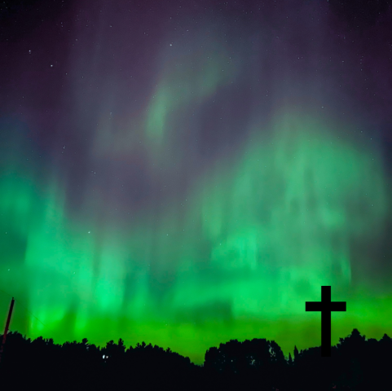
The question “What would Jesus do?” often shortened to the acronym “WWJD,” has graced wrist bands, T-shirts, and bumper stickers since the 1990s. And while it might sound like an overused cliché, it’s a question that can lead our spirit and, by extension, our lives to profound transformation.
What did Jesus do? He crossed a lot of boundaries. In fact, when we think about the boundaries that separate people―things like money, gender, education, culture, religion, and class―Jesus crossed them all, inspiring hope, inclusion, and compassion.
In the same way, our generosity through Mission and Service breaks down walls that divide and builds bridges that draw us together.
Your generosity supports organizations like hospitals, counselling centres, drop-in circles, and homeless shelters that are there when people need them most. Your gifts sustain education programs that teach farming skills, provide job training, and help remove obstacles so children can remain in school. Your generosity stands up for victims of human trafficking, ensures workers and children know their rights, and advocates for those persecuted because of their sexual orientation, gender, or beliefs. It fosters anti-racism, supports healing and reconciliation, and deepens spiritual practice.
Through Mission and Service, the arms of your generosity stretch wide, reaching into schools, camps, hospitals, shelters, prisons, and churches.
Mission and Service is one of our church’s best answers to the question “What would Jesus do?”
Thank you for your support.

