Communion

God be with you
God be with you too.
Lift up your hearts
We lift up our hearts to God.
Let’s give thanks to God.
Thanks and praise to God.

Jesus was a baby, a child, a youth and then an adult.
Jesus loved kids, and told the disciples
To let the kids come to him, to ask questions,
And to hear his stories.
Jesus had great wonder for the beauty of nature.
He spent a lot of time outside, under the sky and the stars, by the rivers and lakes, and under trees.

Sing MV 18 Lord, Prepare Me to Be a Sanctuary

One time, his parents thought that he was lost, but then they found him in a holy place, teaching all the teachers. All of us can teach each other a lot of things: love, friendship, wonder and delight.

Sing MV 18 Lord, Prepare Me to Be a Sanctuary

Jesus loved to play and make things. When he grew up, he became a carpenter. Just like kids of today, Jesus liked to build and create things, making friends, welcoming everyone and trying to help others to see God in new and different ways.

Sing MV 18 Lord, Prepare Me to Be a Sanctuary

So today, we will share a small meal together. Jesus was very good at sharing. He shared God’s love and he shared himself. Alan has shared his craft of baking in the making of this bread, and someone else has shared their juice making skills for the contents of the jug.
Sing MV 18 Lord, Prepare Me to Be a Sanctuary

So we share this meal together, because God loves everyone and welcomes us to the table.
Loving God,
Jesus was a child, with a heart and mind
Open to the wonder of God’s love.
As we, your children of all ages,
Look forward to the sharing of this meal,
We ask your blessing on this bread and this juice,
That they feed our bodies and our spirits,
So that we might be a source of love in the world.
As we share this meal,
We remember that there are some
In this world who yearn for bread.
We remember that there are some
In this world who are lonely.
We remember that there are some
In this world who dream of peace.
As we share together,
We remember and pray that You
Offer what they need through
The hearts, hands and feet
Of those who are helpers.
We pray this and all things
Speaking together the words Jesus taught:

Our father…

Send, O God, your Holy Spirit upon us and upon these gifts, that all who share in this bread and this cup may be the body of Christ: light, life, and love in the world.
Through Christ, with Christ and in Christ,
In the unity of the Holy Spirit, all glory is yours.
God Most Holy, now and forever.
AMEN

Sharing the Bread and the Cup

Communion Anthem Can You Drink the Cup Courtney
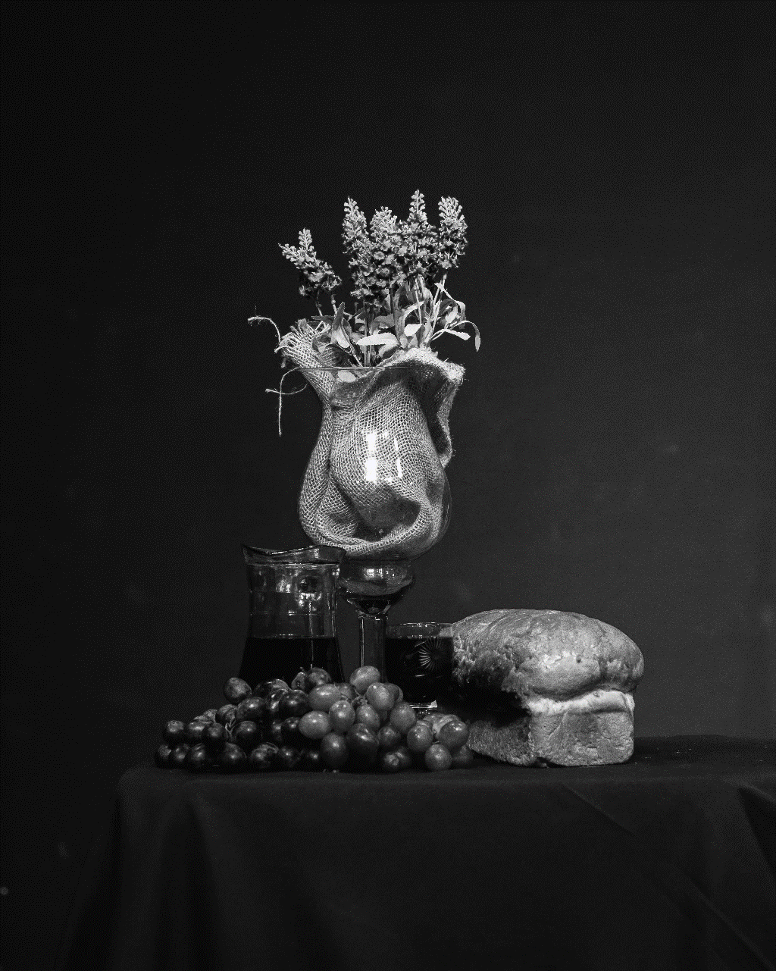
Prayer after Communion
Life-giving God, may we, who share Christ’s body, live his risen life; we, who drink his cup, bring new life to others; we, whom the Spirit lights, give light to the world. Keep us firm in the hope you have set before us, so that we and all your children shall be free, and all creation will live to praise your name.
Amen.

