Westworth United Church
1750 Grosvenor Avenue, Winnipeg, Manitoba
on Treaty One Territory in the heart of the Métis Nation

Friday March 29th, 2024
Good Friday – Stations of Peter

We Gather to Worship

Welcome

Introit This is the Hour of Worship Dorothy Lawson

Gathering Words

Opening Prayer
Holy God,
as we journey through this familiar story,
help us to understand it in a new way.
Show us, O God, where we find ourselves
In this narrative,
And move us toward a more just
And compassionate future.
Through your reconciling grace we pray.
Amen.

Visual Meditation

Station One- Peter resists then receives the foot washing
Scripture: John 13: 1- 20

Through Peter’s Eyes

Congregational Response

Hymn VU 134 Shadows Gather, Deep and Cold

Station Two - Jesus foretells Peter’s denials
Scripture: John 13: 31-38
Through Peter’s Eyes

Congregational Response

Hymn VU 143 My Song is Love Unknown

Station Three - Peter draws his sword
Scripture: John 18: 1-11

Through Peter’s Eyes

Congregational Response
Holy One,
Our world today feels addicted to violence.
We lament the proliferation
and use of weapons and firearms.
We bemoan the staggering statistics of intimate partner violence.
We mourn the abuse of our 2S and LGBTQIA+ family and friends must endure so often.
And we confess our own complicity in the pain of our neighbours and the violent ways of our world.
For we too have uttered harmful words about each other, we have refused to acknowledge another’s pain, we have turned a blind eye to those in need. In doing so we have betrayed the peace you left with us through Jesus. We have built war economies that make conflict profitable. We have created societies that justify the violence of food and housing insecurity, racism, discrimination, homophobia, transphobia, and marginalization. God of Grace, in this hurting and desperate world, have mercy upon us. Amen

Special Music When You Prayed Beneath the Trees
Christopher Idle and Lloyd Larsen

Station Four - Jesus is arrested and Peter denies Christ
Scripture: John 18: 12-18

Through Peter’s Eyes
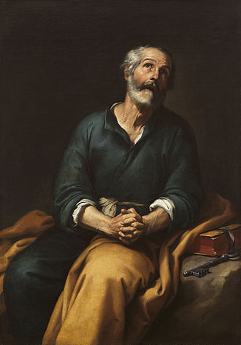
Congregational Response
Merciful God, we confess that, too often, we’ve been inactive bystanders in the face
Of someone else’s victimization.
Forgive us choosing self-preservation
over justice.
Amen.

Special Music Deep Were His Wounds Leland Sateren

Station Five - Peter denies Christ again and again
Scripture: John 18: 19-27

Through Peter’s Eyes

Congregational Response

Station Six - Jesus is Crucified
Scripture: John 19: 1-30

Through Peter’s Eyes

Scripture: John 19: 38-42

Hymn VU 144 Were You There

Parting Words

Hymn VU 182 Stay with Us Through the Night

Postlude Were You There arr. Faye Lopez

QR Code for Westworth donations
Organist: Megan Dufrat
Director of Music: Valdine Anderson
SARH Music Director: Katy Harmer
Coordinator of Children, Youth & Families: Katie Anderson
Minister: Tricia Gerhard

Saint Peter in Tears by Bartolomé Esteban Murillo (1617–1682)

