**Communion Anthem** If We Truly Believe

**The Invitation**

The invitation is simple: come and eat of the feast. Not only a meal to nourish the body, but a banquet offered to feed the soul.

**We receive the bread and the wine connected to the ages: to the saints of old who felt unworthy, to the seeker eager to know God, to the teenager who wonders what it’s all about, to the child who eats with unburdened, uncomplicated faith.**

Woven into this time are the hopes and tears of generations past. But even amid grief, there is a great joy. For we are told that no one is turned away from this table. All are welcomed and offered the peace of Christ. And so with confidence we lift up our hearts.

**We lift them. We offer them. We ask them to be filled.**

Let us give thanks to God.

**It is right to give our thanks and praise.**

Tender transforming God, you have invited us to gather at this table, to taste the feast and to hear the same abundant promises offered to our ancestors in faith. Time and time again you have called us to this place offering us your grace. Reminding us of your love. Gifting us with everlasting life. Even as we turn away from, even when we deny you, you never closed the door on us. And so we join our praises to those of your angels singing to you, our ever-patient, always faithful Creator:

**Sing MV 203 Holy Holy Holy**

O holy, holy holy God

O God of time and space.

All earth and sea and sky above

Bear witness to your grace.

Hosanna in the highest heav’n

Creation sings your praise.

And blessed is the on who comes

And bears your name always!

As we gather in this sacred place

we remember the night in which Jesus was betrayed,

The Bible tells us that he took bread, and gave thanks;

Broke it and gave it to his disciples, saying:

Take eat, this is my body, given for you.

Each time you eat this bread remember me.

After supper he took a cup, gave thanks, to you holy God and gave it to those gathered with him saying;

This cup is a sign of God’s new covenant poured out in my blood, shed for you and for all people for the forgiveness of sin. Each time you drink of this cup, remember me.

And so we gather here and we rejoice that at this table you call us God to remember so many things.

**In this bread and wine we remember your presence with Jesus and how through him we came to know you more clearly**.

In this bread and wine we remember the call offered to us by your Holy Spirit to follow him in faith.

**In this bread and wine we gently hold our aching hearts as we remember all those who have died and who we miss so much. And we vow to honour and celebrate their lives, even as we continue to grieve.**

In this bread and wine we remember all those who continue to walk this path of life and who need your loving guidance: lifting up to you especially those in this community of faith and in our circles of connection those who struggle with loss, health issues, and the unknown

**We pray also for those who struggle under the weight of mental illness, their own and that of those they love.**

In this bread and wine we glimpse the glory of your kingdom and so we pray that you would pour out your Holy Spirit upon all of us gathered here, and upon these gifts of bread and wine.

Empower this table to be a meeting place of lives lived; love shared and hope preserved. Remind us that in this sacrament we are offered a moment where time has no meaning and death has no power.

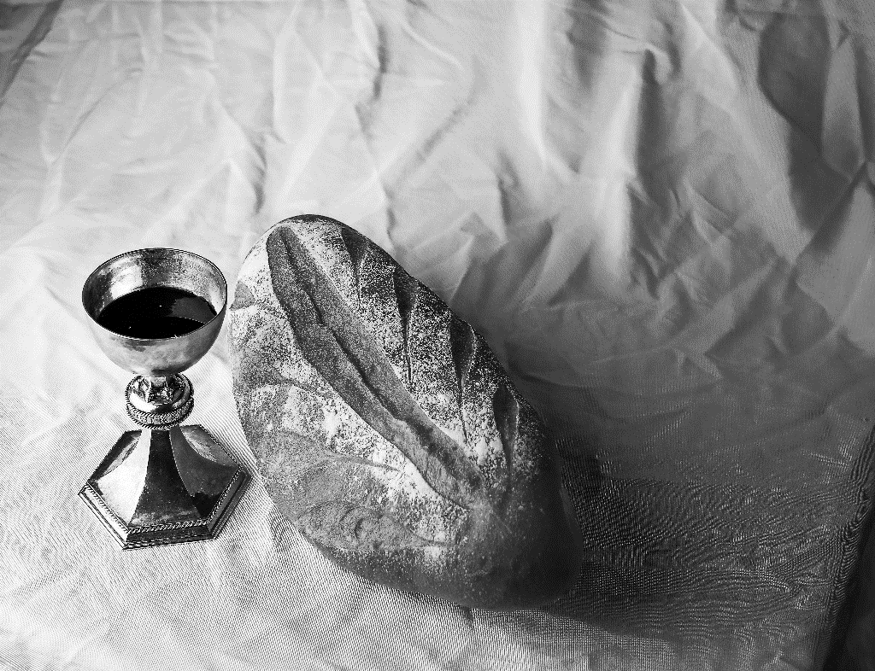

And Help us to know you, our Creator, our Redeemer, our Sustainer of Life. May your Spirit fill us as we remember and sing together the mystery of our faith

**Sing MV 204 Memorial Acclamation**

*Sing Christ has died and Christ is risen,*

*Christ will come again!*

*Sing Christ has died and Christ is risen,*

*Christ will come again!*

We gather these and all our prayers,

Thankful that we may turn to you

As to our Mother who loves us, as to: **Our Father, who art in Heaven…**

**Sing MV 205 Great Amen**

Amen, amen, O Holy One! Hosana and Amen!

Amen, amen, O Holy One, Hosana and Amen!

***Fraction and Distribution***

The body of Christ, broken for you.

**Thanks be to God for the bread of life**

The blood of Christ shed for you.

**Thanks be to God for the cup of blessing**

These are the gifts of God for you the people of God.

**The Sacrament of Communion**