Friends, Advent is a season of waiting.

We wait for Christ to be born.

We wait for the feeling that love is near.

We wait for God’s promised day.

Advent is a season of waiting.

And while we humans are good at many things, waiting is not high on that list. We are an impatient and anxious bunch, eager for the hope of what comes next.

Maybe that’s why the table is such a gift.

For when we come to this table, for just a moment, the waiting stops. When we come to this table, for just a moment, we get a glimpse of God’s promised day.

We get a glimpse of a world where all are fed and all are welcomed. And for just a moment we can believe the angels when they say, “Be not afraid.”

For just a moment, Mary’s words tumble through our minds – words of justice and hope, words like: “the hungry have been filled” and “The humble have been lifted.”

So come to this table.

Come catch a glimpse of what could be.

Come end your waiting, for love is hovering close.

This is what it’s all about.

God is all around us.

So come, this good news is for you.

All are welcome here.

We gather on this first Sunday of Advent

Eager to start the journey towards Christmas,

But also cognizant that the world

Isn’t as we’d hoped it would be.

So we come to the table carrying the prayers of our hearts and minds.

Let us pray:

Loving God,

We come to this table today longing for a new beginning.

In a world that so often feels like its ending,

We crave the hope of a new beginning.

We long to hear from the endings and crash landing

Of our hurting world and start again,

Rooted in your good news.

So week by week, bit by bit, we return to your Word.

Week by week, bit by bit, we return to each other.

Week by week, and bit by bit, we repeat the truths that we so often need to hear,

Trusting that by your grace, it is never too late to start again.

Here at this table, we remember a meal shared among friends, which was the start of something that would changes lives forever. Here are this table, we remember a meal shared among disciples, followers, that would mark the beginning of something new for all of their lives.

Here are this table, as modern-day disciples, we remember that Jesus shared a meal with the people closest to him. During that meal Jesus took some bread, gave thanks for it, and then broke it. He passed those broken pieces and passed them among those at the table saying: “Take, eat. This is my body, given for you. Each time you do this, remember me.” Some time later, Jesus took a cup of wine, and after giving thanks for it, passed it among his friends, saying: “Take, drink. This is the promise of God. Each time you share a drink like this, remember me.” And so this next stage in ministry, this new beginning, began.

So in this spirit of beginnings, we come to the table.

Once more we ask that you would meet us here.

Pour out your Spirit on this ordinary meal, that in this bread and cup we may glimpse a new day.

May the sight of everyone being welcomed at this Table remind us that all are loved by you.

May the evidence that there is food for all remind us that no one is meant to go hungry.

May the fact that our own mistakes, shame and doubt do not keep us from this Table remind us that you welcome and love us as we are.

And may all these truths serve as building blocks for a new day, for a new beginning.

With hope in our hearts, we pray.

With hope in our hearts, we gather.

With hope in our hearts, we begin again.

Meet us here.

Allow this joyful feast to be the start of something new.

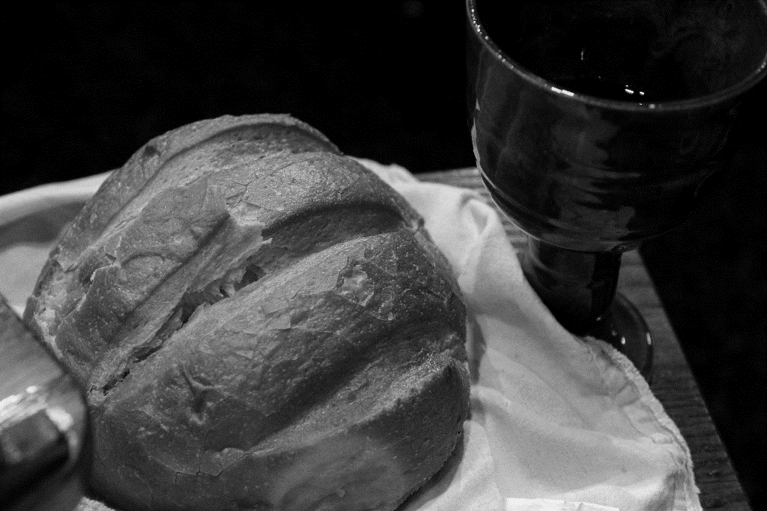With joy and hope, we weave our voices together to pray the words our brother and teacher Jesus taught us to pray, saying *Our Father…*

**Sharing the Elements**

**Prayer After Communion**

Nourishing God,

Sometimes we tell ourselves that too much has taken place to begin again. We think the world is too far gone. We think we have made too many mistakes. We tell ourselves that we couldn’t possibly begin again. But then we come to this Table and we get a glimpse of your kin-dom.

**We come to this table and all are welcomed, all are seen, all are fed.**

**And just like that, we have hope.**

**Just like that, we begin again.**

**Thank you for the gift of this fresh start.**

**Thank you for planting hope deep**

**within our bones.**

**Thank you for meeting us in ordinary bread and juice to remind us that it’s never too late to build your kingdom here.**

**We are grateful.**

**Amen.**

**Sacrament of Communion**

**December 1, 2024**