**Sharing the Story**

**Hymn** MV 126 Are You a Shepherd?

**We Hear the Word**

**Prayer for Illumination**

**Scripture:** Luke 15: 1-7

This is the good news of the Gospel

**Thanks be to God.**

**Anthem** Keep God’s LightM. Patterson

**Reflection**

**Hymn** VU 360 A Woman and a Coin LIFE RESTORED

**We Respond to the Word**

**Offering Invitation**

**Hymn:** TUNE MV173

*In peace we place our offering here*

*Our hope and prayers and compassion.*

*May you, O God, bless all we share,*

*Bring healing to Your Creation.*

**Offering Dedication**

**Prayers of the People and the Lord’s Prayer** (VU921)

**Hymn** VU 266 Amazing Grace AMAZING GRACE (NEW BRITAIN)

**Benediction**

**Sung Amen** VU 971 Amen

**Postlude**Ciaccona Svitlana Ostrova

Reader: Sandy Marles

Pianist: Megan Dufrat

Director of Music: Valdine Anderson

Coordinator of Children, Youth & Families: Katie Anderson

Minister: Tricia Gerhard

Cover Photo: Mihai Pirlitu QR Code for Westworth donations

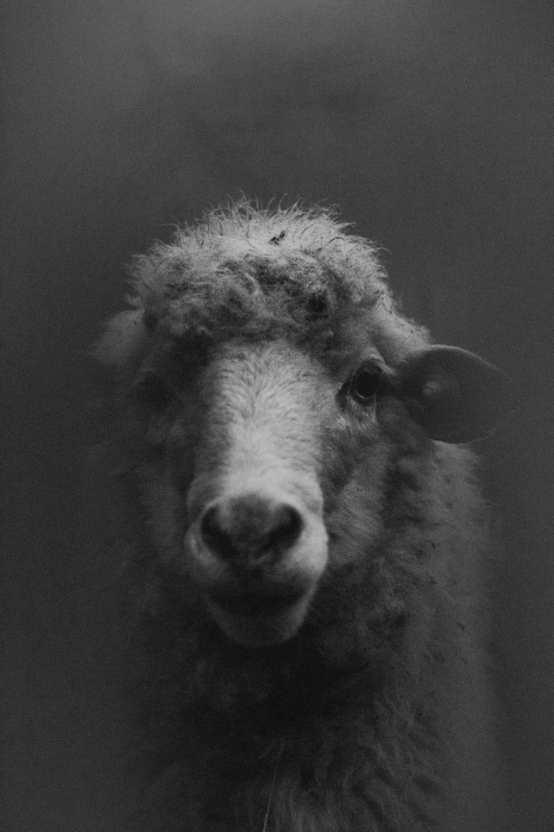

**Westworth United Church**

an Affirming Ministry zhi-kagige-aniishag, nindoodem Treaty No. 1 gii-aniishin, Anishinabe (Ojibwe), Ininew (Cree), Oji-Cree, Dene, mii ottawa Dakota akina. Mii naadamaadwin Métis Nation nindizhinowin, bihkikwe Métis Nation aazhoon.

March 30, 2025

Lent 4 – Everything In Between – Lost & Found

**We Gather to Worship**

**Prelude**

**Welcome & Announcements**

**Introit** Come Unto UsKaren Marrolli

**Call to Worship**

Our God is a Shepherding God.

**Our God knows us by name.**

Our God will never stop searching for us.

So if you feel lost,

**Then know that God is seeking you.**

If you feel found,

**Then know that God will never leave.**

This is the promise of scripture.

**This is the promise of God’s love.**

Let us worship our with-us God

**Opening Prayer**

God meets us in the night –

**Before the sun rises,**

**Before the wound heals,**

**Before there are answers,**

**Before there is closure.**

God meets us in the light –

**Where joy is effervescent,**

**Where laughter is contagious,**

**Where flowers bloom from cracks in the sidewalk,**

**Where people gather around tables.**

God meets us in between –

**At the edge of the water,**

**At the beginning of the wilderness,**

**At the start of something new,**

**On the edge of faith.**

And if God meets us in all those places

**Then surely God meets us everywhere –**

**At the water’s edge, at the start of something new,**

**After the baptism, and before the call.**

We are not alone. God is all around.

**Let us worship the God of everything.**

**Hymn** VU 312 Praise with Joy The World’s Creator

LAUDA ANIMA (PRAISE MY SOUL)

**Call to Confession**

**Prayer of Confession:**

If God is a painter,

**Let us be the brush.**

If God is a musician,

**Let us be the song.**

If God is an architect,

**Let us be the tools.**

**Let us be the hands.**

**Let us be the builders.**

But if God is a shepherd,

Who never stops seeking,

**Let us be willing to be found,**

**No matter how lost we feel.**

Our God is never far away.

**Forgive us for forgetting this good news.**

**Tenebrae Candles**

**Sung Response:** VU 400 Lord Listen to Your Children Praying

**Words of forgiveness**

So hear and believe the good news of the gospel:

**No matter how far we wander, we can never wander from the bounds of God’s grace. We are loved. We are forgiven. We are not alone. Thanks be to God! Amen,**

**The Peace of Christ**