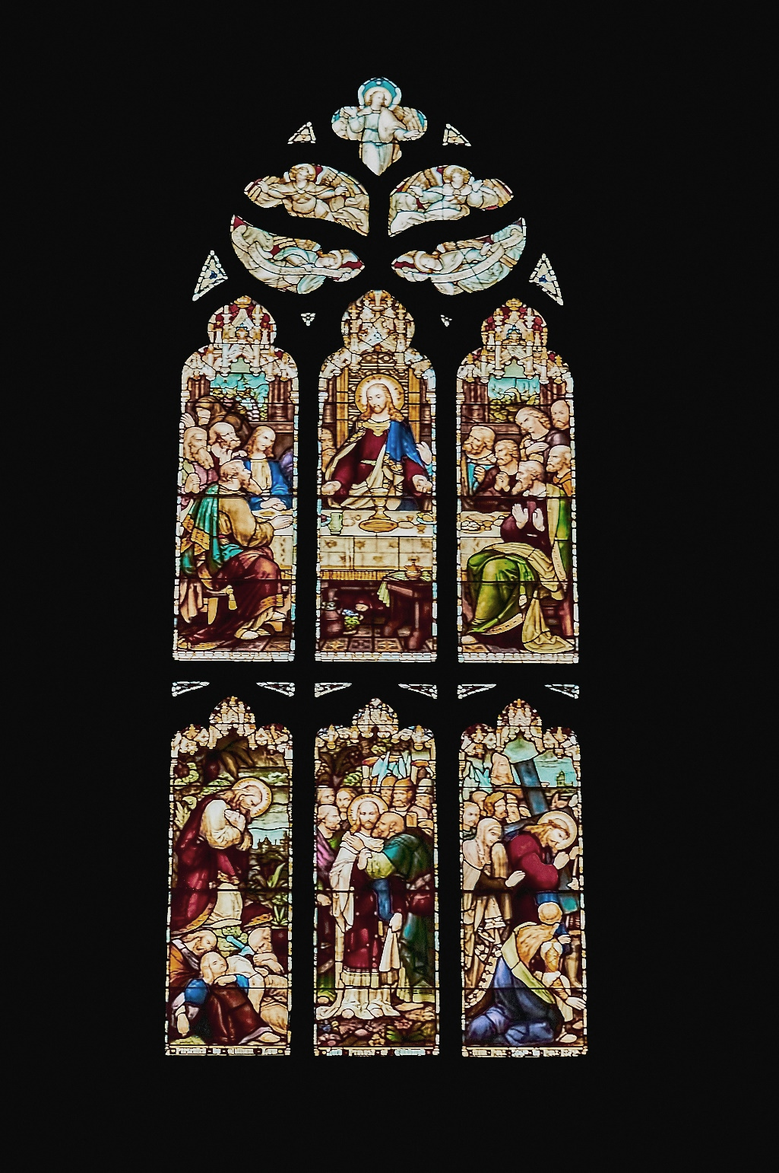

*.*

Reader: Linda Paul

Pianist: Megan Dufrat

Director of Music: Valdine Anderson

Coordinator of Children, Youth & Families: Katie Anderson

Ministers: Karen Lumley & Tricia Gerhard

QR Code for Westworth donations

**St. Andrews River Heights & Westworth United Churches**

an Affirming Ministry located on the lands of

Treaty One Territory

and the homeland of the Red River Métis Nation

April 17, 2025

**Maundy Thursday Service**

**Prelude**

**Welcome**

**Introit** Tristis est anima mea Eleanor Daley

**Call to Worship**

We have come to worship the Trinity,

**One God, three persons, beyond our understanding**

**Yet constantly revealing themselves to us.**

We have come to worship an infinite being

**Who took on finite flesh: fully human and fully divine –**

A being who is love itself,

**Yet loathes injustice;**

who is almighty,

**yet let go of power**

**to be in solidarity with outcasts and criminals.**

We gather to worship the living God

**Who died.**

**Hymn:** MV 75 Veni Sanctus Spiritus J Berthier

*Holy Spirit, come to us,*

*kindle in us the fire of your love.*

*Holy Spirit, come to us,*

*Holy Spirit, come to us.*

*Veni Sancte Spiritus,*

*Tui amoris ignem accende*

*Veni Sancte Spiritus,*

*veni Sancte Spiritus.*

**Scripture:** Luke 22: 7-13

**Invitation to Christ’s Table** (see insert)

**Scripture:** Luke 22: 24-27

**Conversation:**

1. How do you think that Jesus would define power?
2. What does it mean for the greatest to become the least, and for the leader to be like a servant?
3. How can our faith community, or the whole church, lean into Jesus’ servant model of leadership?
4. Have there been times when *you* felt you had to be the greatest, the holiest, the most pious- or that you were not holy enough or good enough? How do you work through those feelings?

**Journeying to the Cross**

**Hymn:** VU 950 Stay with Me J Berthier

*Stay with me, remain here with me,*

*Watch and pray, watch and pray.*

**Depart in Silence**