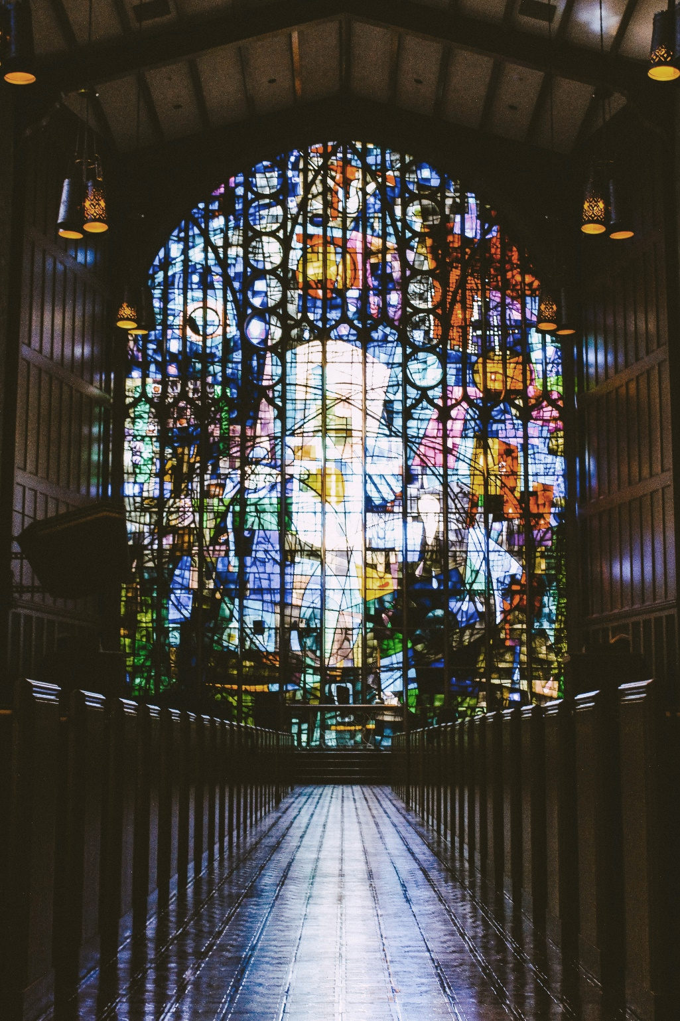
Scripture: Romans 12: 1-2
Hear what the Spirit is saying to the Church.
Thanks be to God.

Anthem The Family We Find Along the Way Mark Burrows
Reflection

Hymn VU 494 Those Hearts We have Treasured RESIGNATION

We Respond to the Word

Offering Invitation

Hymn VU 518 As Those of Old Their First-fruits Brought (v.3 only) FOREST GREEN

Offering Dedication

Prayers of the People

Hymn VU 481 Sent Forth By God’s Blessing THE ASH GROVE

Benediction

Sung Amen VU 974 Amen

Postlude Study in D Major for Left Hand Felix Swinstead


Reader: Shirley Watts QR Code for Westworth donations
Communion Servers: Rachael & Alex Doerr, Rhea Yates, & Christine Strike
Pianist: Megan Dufrat
Director of Music: Valdine Anderson
Minister: Tricia Gerhard

Prayer written by Joanna Harader, posted on the Spacious Faith Blog. www.spaciousfaith.com/

Westworth United Church
an Affirming Ministry located on the lands of
Treaty One Territory
and the homeland of the Red River Métis Nation

November 2nd, 2025 – All Saints - Communion
The Story of our Faith – a Safe Place to Land

We Gather to Worship

Prelude

Welcome & Announcements

Introit Jesu, Our Blessed Hope of Heaven Gordon Young

Call to Worship
We have gathered in this place to worship,
Because Jesus invites us to.
We come just as we are, with our faith and our doubts,
With our successes and our failures,
With our joys and our sorrows,
Because Jesus invites us to.
We come with what we have,
Bringing with us the events and experiences
of this past week, month, year because Jesus invites us to.
We come,
trusting that what we carry and how we are feeling,
is important to God because Jesus invites us to be here
Jesus is the one who said, “Come to me all, you that are weary and are carrying heavy burdens, and I will give you rest. Take my yoke upon you, and learn from me; for I am gentle and humble in heart, and you will find rest for your souls.”
We come, because Jesus invites us, every single one of us,
to this moment and this place.
Opening Prayer

Opening Hymn MV 62 There is Room for All Bruce Harding

Prayer seeking Reconciliation
“Come, you who are weary, come rest in this place of peace.”
These are the words that call us in,
This is the love that welcomes us here.
This is the faith we cling to, Loving God,
In good times and in bad.
As we gather on this holy day,
As we tell our stories,
Share our memories,
Weave our laughter and our tears together,
Help us feel You with us.
Forgive us those moments when our hearts falter,
When our doubts overwhelm.
Remind us that You are the One who offers
A safe shelter for our weary hearts,
And that all are welcome here.
-Silent prayer of confession –

Assurance of Grace

Sung Response MV 85 Take, O Take Me As I Am
John L. Bell & Graham Maule

The Peace of Christ

Celebrating Communion

Communion Anthem Can You Drink the Cup Craig Courtney

Prayer after Communion

Hymn MV 196 We Will Take What You Offer John L. Bell

We Hear the Word

Scripture: Matthew 13: 31-32
This is the good news of the Gospel.
Thanks be to God.

