We Hear the Word

Scripture Reading: Psalm 78
These are the words of our faith.
Thanks be to God.

Scripture Reading: Matthew 13: 33-36
These are the stories of our faith.
Thanks be to God.

Anthem Abide with Me Jason Locke

Sermon

Hymn VU 678 For the Healing of the Nations WESTMINSTER ABBEY

We Respond to the Word

Offering Invitation

Music During the Offering – Westworth Winds Community Band
Holy, Holy, Holy John B. Dykes Arranged by Wayne Stevens

Offertory VU 518 In Gratitude and Humble Trust (v.3 only) FOREST GREEN

Offering Dedication
The stories of our faith ground us in the ministry You call us to embrace. The invitation You give is for us to take our place within this larger story. May Your Spirit bless what has been given here, O God, and may we be aware of Your movement in and through the work we do together. Amen

Prayers of the Community

Hymn VU 684 Make Me a Channel of your Peace CHANNEL OF PEACE

Benediction

Sung Amen VU 974 Amen

Postlude – Westworth Winds Community Band
Abide With Me William Henry Monk Arranged by Earl Isaak of Winnipeg
Westworth Winds Conductor: Ray McClelland

Trumpet: Rick Sellwood Oboist: Ruth Denton
Reader: Sandy Marles
Organist: Dorcas Windsor
Director of Music: Valdine Anderson
Minister: Tricia Gerhard QR Code for Westworth donations

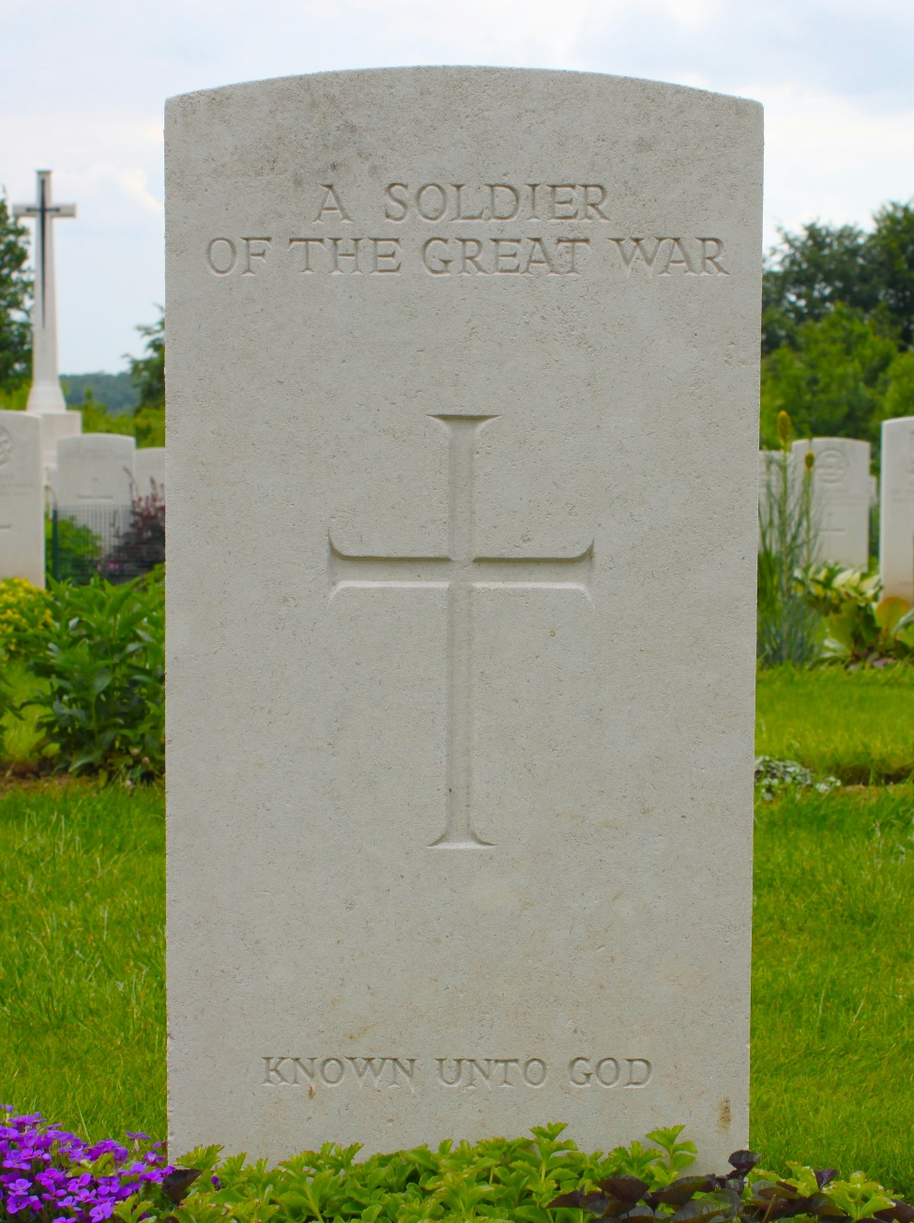

Westworth United Church
an Affirming Ministry located on the lands of
Treaty One Territory
and the homeland of the Red River Métis Nation

November 9th, 2025
Remembrance Sunday – Creating Peace through Small Acts

We Gather to Worship

Prelude: Westworth Winds Community Band
God Still Lives! Eternal Father, Strong to Save
O Day of Peace Fanfare for the Common Man

Welcome & Announcements

Introit In Flanders Fields Eleanor Daly

Centering Words

Lighting the Christ and Peace candles

Call to Gather & Opening Prayer:
In times of war, in times of peace -
The Creator is present.
On the battlefield, at the peace table –
The Christ is present.
With those wounded and the dying,
And with those who wait –
The Spirit is present.
And what is God doing?
Grieving over the injustice.
Grieving over the brokenness.
Grieving over the loss.
And?
And calling us back
To repentance,
To renewal,
To life abundant,
To peace.
So today, in our remembrance, in our songs, in our prayers…
Let us worship the One who is with All,
No matter what.
Let us worship God as we remember.

Hymn VU 34 Come Now, O God of Peace O-SO-SO

Prayer Seeking Reconciliation
…We meet your boundless grace with judgment and revenge.
In the presence of your peace, in the confidence of your love, we confess our failings and wrongs, turning from that which harms ourselves, our neighbours and you. Meet us in our brokenness, Loving God, and journey with us on the path to peace.

Gift of Grace

Sung Response MV 67 Kyrie Eleison John L. Bell

The Peace of Christ

Ritual of Remembrance

Words of Remembrance

Pictorial Memories – Westworth Winds
A Hymn for Band Composed by Hugh Stuart

Last Post
…We will remember them
We will remember them.

Minute of Silence

Reveille
They were young, as we are young
They served, giving freely of themselves.
To them, we pledge, amid the winds of time,
To carry their torch and never forget.
We will remember them.
We will remember them.

Hymn VU 527 God! As with Silent Hearts ST AGNES (LANGRAN)

Words written by Roddy Hamilton, posted www.re-worship.blogspot.com
Written by Rev. Richard Bott. Gathering, Pentecost 2 2025, page 47 Used with permission

