Gave thanks to God for it,
And broke it, passing the pieces to those at the table.
As he did, Jesus said: “Take, eat. This is my body broken for the world.
Each time you bread together, remember me.”
Later, Jesus took a cup and gave thanks for the wine in it,
And he passed it to his friends,
Saying “take, drink. This is God’s promise of forgiveness.
When you share this cup, remember me.”

With this story echoing in our hearts and minds,
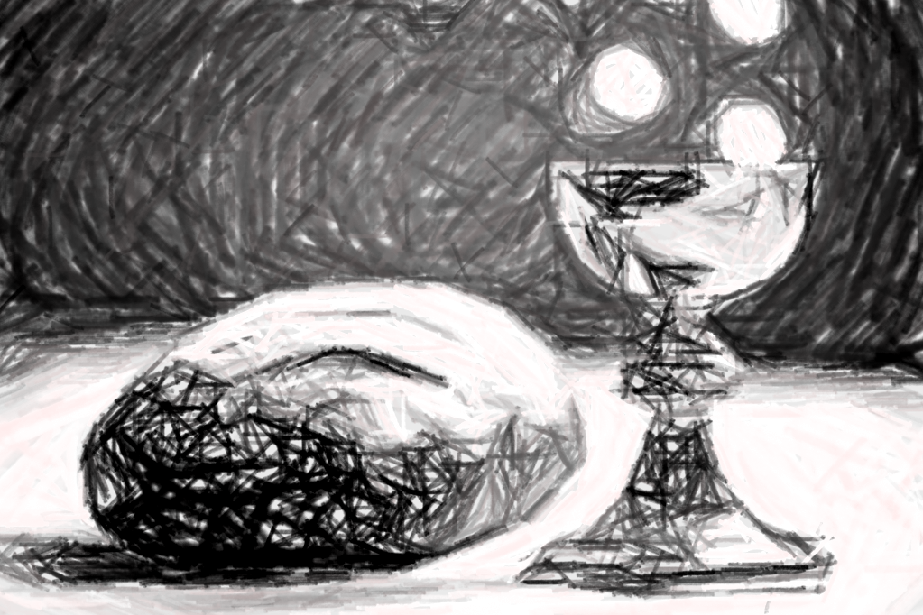
We join our voices together to proclaim the mystery of our faith:
VU 933 Memorial Acclamation

And we pray:
Gracious God, pour your Spirit on us,
And these gifts of bread and juice,
So that this simple meal reminds us
That your love and grace is found in the ordinary things of life,
Keep us breaking bread together as a joyful neighbourhood.
We lift this prayer, and all the prayers of our hearts and minds to you, using the words recited by generations of believers, saying the prayer Jesus taught:
Our Father, who art in heave, hallowed be thy name.
Thy kingdom come,
Thy will be done on earth as it is in heaven.
Give us this day our daily bread,
And forgive us our trespasses
As we forgive those who trespass against us.
And lead us not into temptation,
But deliver us from evil,
For thine is the kingdom, the power and the glory,
Forever and ever. Amen.
VU 933 Great Amen

Sharing the Bread and the Cup.

Communion Anthem Come My Way William Cross

Celebrating the Sacrament of Communion

Mr. Rogers Neighbourhood started the same way (or almost the same way) for the entirety of its life. From the song he sang as he came in, to the taking off of his coat and the donning of his cardigan, to the changing of his good shoes for runners, to the feeding of his fish. He would often do this while talking about what he was doing, and sometimes he did it in silence. Or at least he did until one day when a five year old blind girl who listened to the show each week wrote to Mr. Rogers to say that when Fred didn’t talk about what he was doing, she worried he wasn’t feeding his fish. From that day on, it became part of the opening ritual that Fred would tell the audience that he was feeding his fish, so this one little girl amongst millions, wouldn’t worry about the fish going hungry.

When we celebrate communion, we have words and actions that describe what we are doing. We tell the story of our faith ancestors, and we tell the story of the last supper. But what makes this meal very special is the presence of God’s love and grace which is given to each of us. This is also a reminder of God’s love and welcome for all, because all people are welcome to come and have communion – for we are a neighbourhood of disciples, just as we are right now. So let us celebrate together

Great Thanksgiving and The Lord’s Prayer

God be with you
And also with you
Lift up your hearts,
We lift them up to God.
Let us give thanks and praise to God
It is right to give thanks and praise.

We give you thanks, O God,
You who made all that is seen and unseen.
You scattered the planets and galaxies in space,
And fill sky, water and land with life.
You made us from dust and clay
And breathed your spirit into us,
Making us in your image,
Each of us special and worthy of love.

We give you thanks, O God,
That you have been part of our story
Since the very beginning.
You brought your people slavery to freedom.
You gave laws so that people would love each other –
Especially those who need help.
You sent prophets and wise ones
To help your people when their neighbourhoods
Were full of greed and violence.
You broke into the story over and over again,
To tell us that you loved us no matter what.

Then you moved into the neighbourhood yourself,
Coming to us in Jesus,
Who was human and did human things –
He ate, played, sang, and lived just like us
And he also healed, taught, warned and loved us.
His idea of neighbour scared the people in power
And out of that fear they arrested him
And put Jesus to death.
But even death could not stop Jesus’ love.
Three days later, Jesus rose from the grave
And showed us that love can persist in the harshest time.
This is why we praise you
Joining our voices with the prophets, elders and disciples everywhere singing:
VU 932 Holy, Holy, Holy

We remember that on the night he was betrayed,
Jesus had a meal with his closest friends and disciples.
While they were eating, Jesus took a loaf of bread

