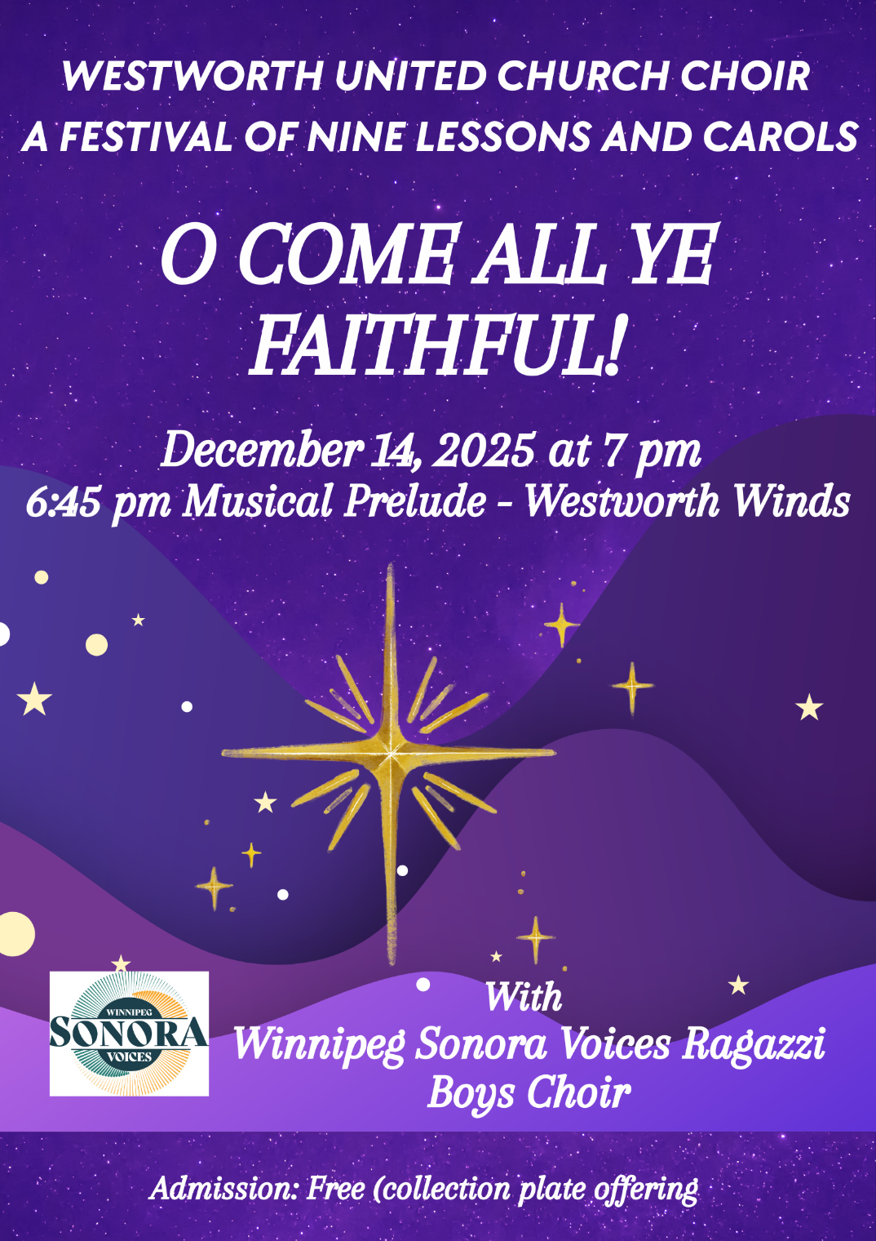

Pianist: Megan Dufrat Donations Table: Neil Arnason
Director of Music: Valdine Anderson Minister: Tricia Gerhard
Conductor, Westworth Winds: Ray McClelland
Special Guests: Westworth Winds & Winnipeg Sonora Voices Ragazzi Boys Choir

Please join the Westworth choir choristers and readers after the service for a reception in the gym following the service.
Thank you to Reverend Tricia Gerhard, Teresa Sztaba, the Westworth Choir Executive Board, Ray McClelland and the Westworth Winds, and to Winnipeg Sonora Voices Ragazzi Boys Choir, to the Westworth Community Care committee and Sharon Stanley for their help, to Dorcas Windsor - guest pianist, and to our readers!



The musicians are pleased that you were able to join us this evening to mark this Season of Advent and to join in anticipation of Christmastide.

Westworth United Church
A Festival of Nine Lessons and Carols – December 14th, 2025

A cash offertory will take place mid-way through the service, and credit card donations are gratefully accepted in the narthex of the church. All proceeds will be divided equally between the Music Enhancement Fund and the church’s General Fund. Thank you for your support!
Please take care to silence your electronic devices before the service begins. If you would like to record the music, please be considerate of those around you, and refrain from applause throughout the service. Thank you!

Prelude: Westworth Winds – Christmas Selections
O Come Emmanuel
Carol of the Bells
La Fete de Noel
A Christmas Suite

Processional Hymn: VU 62 Once in Royal David’s City
Verse 1 solo
Verses 2, 3, 4 congregation and choir
Soloist: Isabelle Buisson

Lesson 1: Genesis 9: 12-16
Reader: Reverend Tricia Gerhard

Hymn: VU 61 Of the Father’s Love Begotten DIVINIUM MYSTERIUM

Lesson 2: Micah 5:2-4
Reader: Christine Strike

Anthem: Torches John Joubert

Hymn: VU 64 O Little Town of Bethlehem ST LOUIS

Lesson 3: Isaiah 9: 2; 6-7
Reader: Neil Arnason

Hymn: VU 44 It Came Upon a Midnight Clear CAROL

Anthem: O Magnum Mysterium Mortem Lauridsen

Lesson 4: Isaiah 11: 1-3a, 4a, 6-9
Reader: Rachael Doerr

Anthem: There is No Rose Kenneth Mahy
soloist: Juliana West

Lesson 5: Luke 1: 26-35, 38
Reader: Sophia Gerhard

WSV Ragazzi Boys Choir: The Gentle Donkey David Ouchterlony

Offertory: Westworth Winds
Adeste Fideles

Hymn: VU 91 The First Noel THE FIRST NOWELL

Lesson 6: Luke 2: 1; 3-7
Reader: Ian Baragar

Quartet: Still, Still, Still traditional Austrian carol arr. Walter Ehret
Juliana West, Isabelle Buisson, Riley Walker, Charleton Rodriques

Lesson 7: Luke 2: 8-16
Reader: Dorcas Windsor

Anthem: Wexford Carol traditional Irish carol, arr. Elaine Hagenberg

Lesson 8: Matthew 2: 1-12
Reader: Rhea Yates

Anthem: For Unto Us a Child is Born (Messiah) Handel

Hymn: VU 59 Joy to the World ANTIOCH

Lesson 9: John 1: 1-14
Reader: Reverend Tricia Gerhard

Anthem: O Come All Ye Faithful traditional Latin Hymnarr. by Dan Forrest
Guest Pianist: Dorcas Windsor

Hymn: VU 48 Hark, the Herald Angels Sing MENDELSSOHN

Benediction

