We Hear the Word

Scripture: Isaiah 60: 1-6
Hear what the Spirit is saying to the church.
Thanks be to God.

Scripture: Matthew 2: 1-12
This is the good news of the Gospel.
Thanks be to God.

Anthem

Reflection

Hymn VU 96 Will You Come and See the Light KELVINGROVE

We Respond to the Word

Offering Invitation

Offertory VU 55 In the Bleak Midwinter (v.3) CRANHAM

Offering Dedication

Prayers of the People and The Lord’s Prayer

Hymn VU 87 I am the Light of the World LIGHT OF THE WORLD

Benediction

Sung Amen MV 220 Hope Shines Janet Bauman Tissandier

Postlude La Estrellita (The Star) Manuel Ponce


Communion Servers: Arlene Hintsa, Al Mapes, Jennifer & Norm Snyder
Reader: Sandy Marles
Pianist: Megan Dufrat
Director of Music: Valdine Anderson
Minister: Tricia Gerhard QR Code for Westworth donations

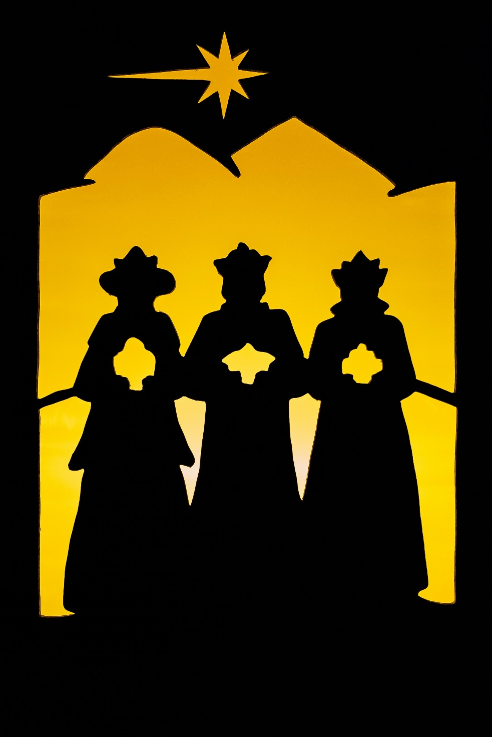

Westworth United Church
an Affirming Ministry located on the lands of
Treaty One Territory
and the homeland of the Red River Métis Nation

January 4th, 2026
Epiphany – Star Words – Communion
We Gather to Worship

Prelude

Welcome & Announcements

Introit

Call to Worship
People of God, arise, shine, for your light has come!
The light of Christ has come into the world.
Immanuel. God with us.
So arise, shine, for your light has come!
And we follow the light –
When it shines brightly in the night sky
When it glows dimly on the horizon.
We will follow the light –
When it leads down familiar paths to expected destinations
When the road is unfamiliar and
the star rests above a dubious looking home.
We will lift up our eyes and look around.
And when we see the Christ Child,
May our hearts be overwhelmed with joy.
When we are in the presence of Immanuel,
May our knees bend in worship.
When our journey brings us, finally, to the heart of God,
May our hands be open in generous sharing;
May our mouths open in generous praise.
With open hearts and open minds, let us come together for worship.
This is our prayer, amen.

Hymn VU 79 Arise Your Light Has Come FESTAL SONG

Prayer Seeking Reconciliation
The prophet speaks of the coming light of God
Which calls all people of the earth to come together
In God’s realm of shalom.
Let us confess the ways in which we have turned away
From God’s vision of wholeness.
God of light and darkness,
We have seen the glimmer of your star-light beckoning to us,
But we have turned away and followed other paths.
We confess that we have not loved you with all our heart,
With all our soul, with all our mind, and with all our strength.
We have not loved our neighbours as ourselves.
Forgive us, Holy One.
Strengthen our steps and guide us in your way of peace. Amen.

Assurance of Grace

Sung Response VU 247 Jubilate Deo TRADITIONAL

The Peace of Christ

Holy Communion

Prayer after Communion
God of Stars and long journeys, God of Epiphany promises, God of hope, we have shared in your meal.
May the eating and the drinking of this meal fill us with hope in a world of despair. May we be beacons of hope as we journey towards a world transformed. May this meal nourish us body and spirit. Amen

Prayer written by Joanna Harader, posted on Spacious Faith Blog, and sources from www.re-worship.blogspot.com

