Holy Communion

God is with us,
We are not alone.
We give thanks for love born in a manger
We give our thanks and praise.

Creating and Creative God,
you brought order out of chaos
and gave light and dark to the world.
You scattered the stars in the night,
And gave life to the earth, sea and sky.
You gently coaxed up plant from the soil,
And heaved mountains from the ground.
You gathered dust and earth,
And breathing life into it, created us in your image.
You filled us with your love, your hope and your courage.

You set us on a path so that we might be heralds of your dreams,
But we strayed from that path,
Tempted by the ways and thoughts of the world.
Throughout history you have sent us prophets, elders, teachers
To help us turn our ways back to you,
Reminding us of the endless love you have for us all
And of the promised justice that is part of your kingdom.
They came in the midst of hopelessness
And filled the people with hope
When that wasn’t enough to convince us of your presence,
You came to a young Mary
and laid out your promise of love in new way.
You told her of a child, her child, named Jesus,
Who would change the world.
The birth of Mary’s child was announced by the appearance
Of a star, a star so bright that even the Magi knew to follow it
For surely it marked something important.
Today, we follow that star to the manger,
To Jesus and the love that he shares.
Today, we follow that star and those Wise Ones to this table.
In awe of this child, we join our voices together to proclaim:
MV 203
O holy, holy, holy God.
O God of time and space.
All earth and sea, and sky above
Bear witness to your grace.
Hosanna in the highest heaven
The stars sing your praise.
And blessed is the One who comes
And bears your name always.
Even with the star in the sky, calling attention to the birth of Jesus,
We remember the life that this wee one will live.
We remember how Jesus broke the bonds of human tradition to show humanity what love and justice could look like as he ate with the outcast and the stranger.
We remember one special meal that he ate with his disciples and his closest friends.
Just like the star drew the Magi, Jesus drew his friends together in an upper room to share in the story of liberation.
As they gathered around the table, they ate and talked together. During the meal, Jesus took a loaf of bread, blessed it and broke it. Then he passed it to his friends saying:
Take and eat. This is bread of life. When you break bread together, do so in remembrance of me.
After the meal, Jesus took a cup, blessed it, and passed it around to everyone at the table, saying:
Take and drink. This cup is the sign of God’s promise. Whenever you drink it remember me.
Following the star and celebrating the birth of Jesus, we remember his life, his death, and his resurrection.
We remember how he poured his love out for all he met and we hope for his return bringing justice, peace and love.

And in our remembering we sing the mystery of faith:
MV 204
Sing Christ has died and Christ is risen,
Christ will come again! (x2)

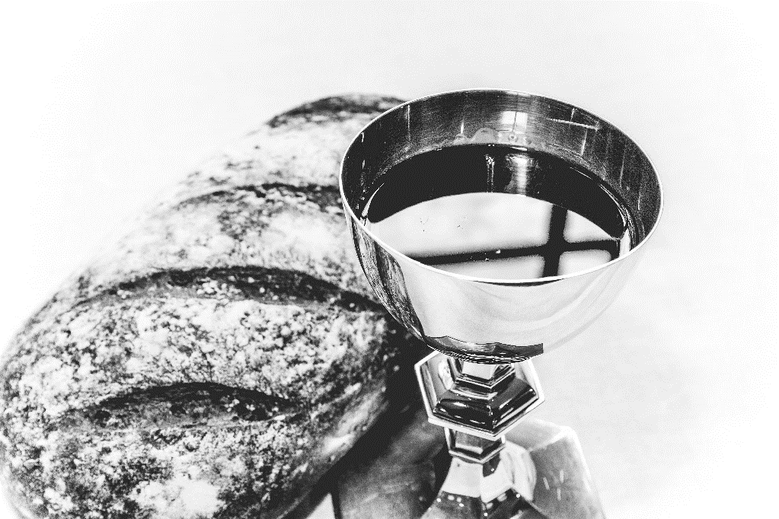
God, you poured out your Spirit on Mary and she sand words of defiance and hope. You sent a star as a sign of Jesus’ birth and the Magi came to mark his importance to the world. We ask that you pour out your Spirit upon us gathered here. As we eat and drink may we know your presence. As we eat and drink may we be opened to the possibilities of your hope and love. Fill this bread and wine with your spirit so that we might be filled with the courage of the Magi to journey to where we are called.
And the people sang:
MV 205
Amen, amen, O Holy One!
Hosanna and amen!
Amen, amen, O Holy One!
Hosanna and amen!
And now, as your beloved, we pray:
Our Father, who art in heaven…

The Pouring, Breaking and Serving

