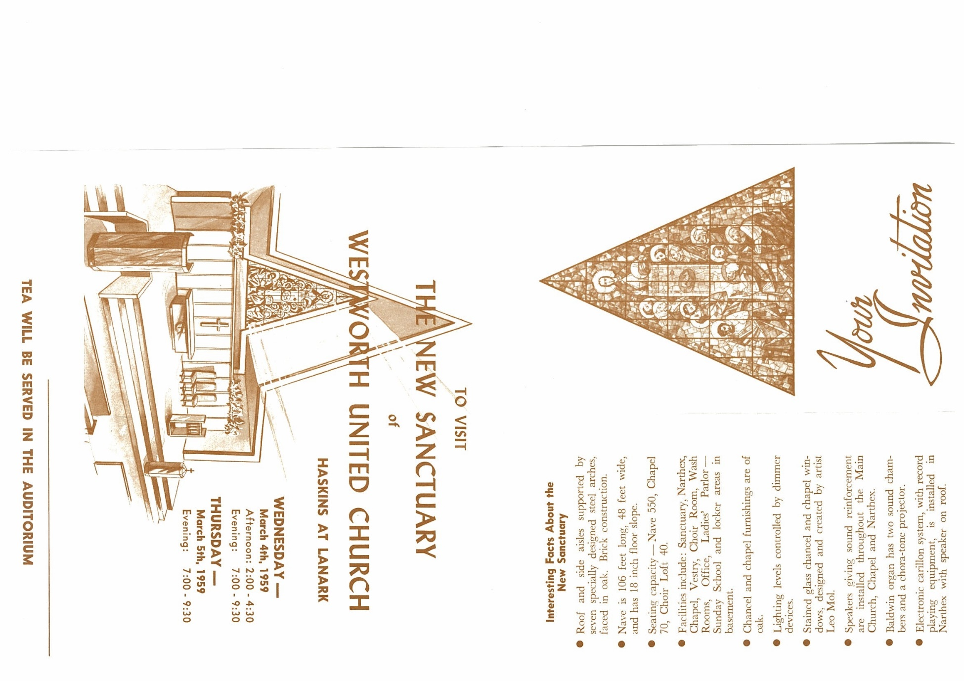
Anthem Come, Blest of my Father Jan Sanborn

Reflection

Hymn VU 713 I See a New Heaven I SEE A NEW HEAVEN

We Respond to the Word

Offering Invitation

Offertory

Offering Dedication

Closing Prayer

Hymn VU 646 We Are Marching SIYAHAMBA
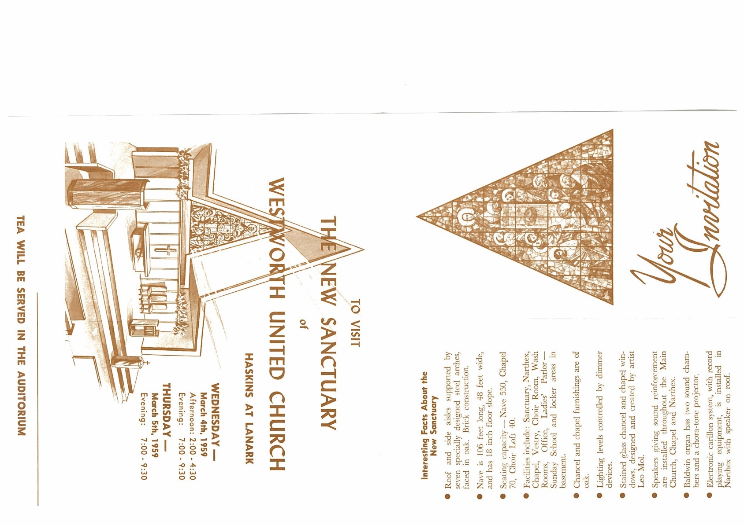
Benediction

Sung Amen VU 971 AMEN Paul Merritt

Postlude Voluntary in G Major William Walond


Communion Servers: Kent & Barb Magarrell and Ray & Judy Steen
Communion Reader: Alex Doerr
Reader: Kathy Wilson
Pianist: Megan Dufrat
Director of Music: Valdine Anderson
Minister: Tricia Gerhard QR Code for Westworth donations

Westworth United Church
an Affirming Ministry located on the lands of
Treaty One Territory
and the homeland of the Red River Métis Nation

February 1, 2026
What We Live By – Sent Out: living out love - Communion
Value: We reach out

We Gather to Worship

Prelude

Welcome & Announcements

Introit Sun of the World Nancy Telfer

Call to Worship
We come, for God gathers us here,
With that community called faith:
Where the hungry are served first,
Where the thirsty drink life’s water.
We come, for God welcomes us here
Into that home called grace:
Where the naked are clothed in robes of hope;
Where the stranger is embraced as the long-lost prodigal.
We come, for God reunites us here,
Siblings in that family called love:
Where the imprisoned model justice,
Where the sick are cradled in God’s peace.
We come, for we are called, welcomed and reunited here in this place and through our worship are empowered to serve here and in the world.

Hymn MV 1 Let Us Build a House TWO OAKS

Prayer seeking Reconciliation
Holy One
We long to be faithful stewards of your abundant grace.
To serve each other in love and humility.
To serve your world with wisdom and energy.
Forgive us when we stumble over pride,
When our words and actions are not guided by love.
Turn our hearts when we act in folly.
Restore our energy when it is gone.
Sometimes, many times, O God, our efforts fail.
But your abundant grace is strong and eternal,
And your forgiveness is limitless,
Which is why we turn to you now
With our own prayers
(Silent Prayer)

Assurance of Grace

Sung Response VU 825 (Refrain only) Michael Baughen

Sharing the Peace

Holy Communion

Hymn VU 465 Christ, Be Our Host EARTH AND ALL STARS
Vs. 1 All Vs. 2 Upper Voices Vs. 3 Lower Voices Vs. 4 All

We Hear the Word

Scripture: James 2: 14-17
Hear what the Spirit is saying to the church.
Thanks be to God.

Scripture: Matthew 25: 34-40
This is the good news of the Gospel.
Thanks be to God.

