So may we live this truth in our every day lives as we pray for your blessing to fall upon us and these gifts.
May we share the hope we find at this table with our neighbours.
May we look for you in our midst.
May we feel you with us as we break this ordinary bread and pass this ordinary cup.
And may we always remember: alleluias came after the grave.
As we live as Easter people. Let us continue to pray the words Jesus taught us to pray, saying
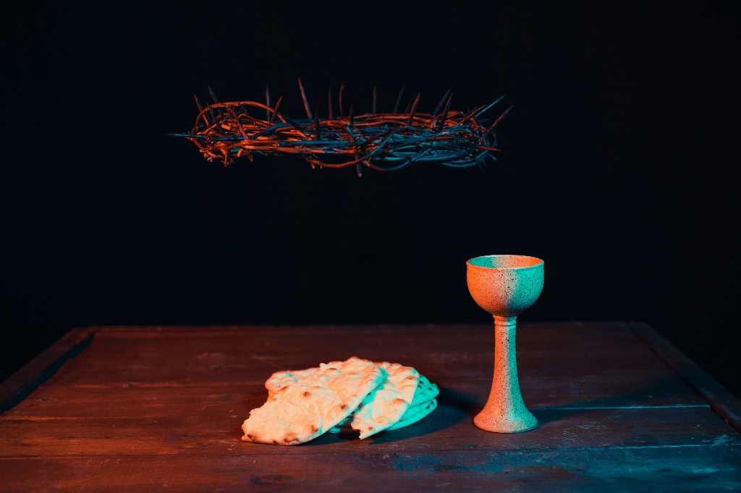
Our Father…

Words of Remembrance
Distribution of the Elements
The Body of Christ broken for you
Thanks be to God for the Bread of Life
The Cup of Christ poured out for you
Thanks be to God for the cup of Blessing.

Prayer After Communion
Loving Christ,
thank you for the bread that nourishes our bodies.
Thank you for the cup that quenches our thirst.
Thank you for this community of faith,
which reminds us of who we are.
Thank you for this table that brings us together.
Thank you for the promise that at this table,
And at every table,
You will be there.
May this holy meal empower us to go out into the world speaking of your good news until we meet here again.
With joy and hope, we pray. Amen.

Communion Easter Sunday
April 5, 2026

Communion
Friends, this is a feast in celebration of the Resurrection – the miracle, the mystery, the hope that envelopes us on Easter Morning! This celebration is not just for some but is for all of us gathered here in this place. No matter how often you come, no matter who you are, no matter where your faith journey has taken you, YOU are welcome to the table. You just as you are in this moment, a beloved disciple of Christ, a beloved of God’s heart. So come and let us share this meal together.

Christ is risen!
Christ is risen indeed!
We should give thanks!
Thanks and praise to the One who brings and renews life!

Risen Christ,
Good-News God,
Ever-present Spirit
We’ve been waiting for the holy mystery of this morning.
We’ve been waiting for the good news of this empty tomb.
We’ve been waiting for the sound of alleluias.
And now that we’re here, all we can really say is thank you.

Thank you for showing the world what could be.
Thank you for your word that guides our steps.
Thank you for facing death and returning with mercy.
Thank you for grace unending.
And thank you for meeting us here, as you always do,
With hope and peace and abundantly lavish love.

Today we celebrate the good news that you are alive in the world.
The grave couldn’t hold you.
Death couldn’t keep you.
The empire couldn’t confine you.
Instead, you are here and everywhere.
You are risen!
In love, you meet us at this Table and remind us that all are welcome here.
And we rejoice for all of this is good, good news.

On this Easter Sunday, this holiest of days,
We ask for your help noticing you in our midst.
When our feet walk beside wildflowers, may we think of you.
When the stars light up the sky, may we see you.
When we break bread with our neighbours, may we feel you.
When a stranger acts with kindness and love,
may we recognize you.
We know that you are out in the world, God, and we don’t want to miss a minute of it.
So we ground ourselves in the mystery of our faith by proclaiming
Christ has died
Christ has risen
Christ will come again.

And while we offer these prayers of gratitude and joy,
We also pray for those who still finds themselves
at the foot of the cross.
We pray for those paralyzed by the pain of Good Friday.
We pray for those who find themselves trapped in war torn areas.
We pray for the leaders of the world, that they would open their minds and hearts to your grace and peace.
We pray for your earth as creation continues to cry out
We pray for those who are ill
We pray for those who are grieving, who are lonely, who are struggling with illness or awaiting diagnosis and prognosis.
We remember those in this community of faith and those in our circles of family and friends who yearn for your presence, your comfort, your healing. We remember…

Holy One, so many days feel like Good Friday,
But the promise of Easter is that Good Friday does not have the last word.

