Anthem

Reflection “Earth Day, Ten Years Later” Rev. Dr. Peter Denton

Hymn MV 173 Put Peace into Each Other’s Hand Fred Kaan, Ron Klusmeier

We Respond to the Word

Offering Invitation

Offertory VU 179 Hallelujah, Hallelujah Give Thanks ALLELUIA NO 1
(Chorus Only)

Offering Dedication
With our time, with our talents, with our treasures and with our trust, we respond to the cries of Creation. Bless our actions in this offering, and may they bear fruit beyond our imagining, for the sake of your Creation. Amen

Prayers of the People and the Lord’s Prayer

Hymn MV 154 Deep in our Hearts FREED

Blessing and Benediction

Sung Amen VU 974 Amen Jim Strathdee

Postlude


Reader: Paul Galbraith
Coordinator for Children, Youth and Families: Rachael Doerr
Pianist: Megan Dufrat
Director of Music: Valdine Anderson
Minister: Tricia Gerhard
Spring Flowers in Tehran (2016)
Guest Preacher: Peter Denton QR Code for Westworth donations

"Rev. Dr. Peter Denton is no stranger to Westworth. He (and his children, Ruth and Daniel) were part of the congregation from 2001-2014 when his partner, Rev. Mona Denton was in team ministry here.
He is a member of the Order of Ministry, and continues to teach at UWinnipeg and UManitoba after retiring from Red River Polytechnic in 2015. A writer and activist, he is the author of nine books, including Gift Ecology: Reimagining a Sustainable Future (2012) that we will talk about after the service today."

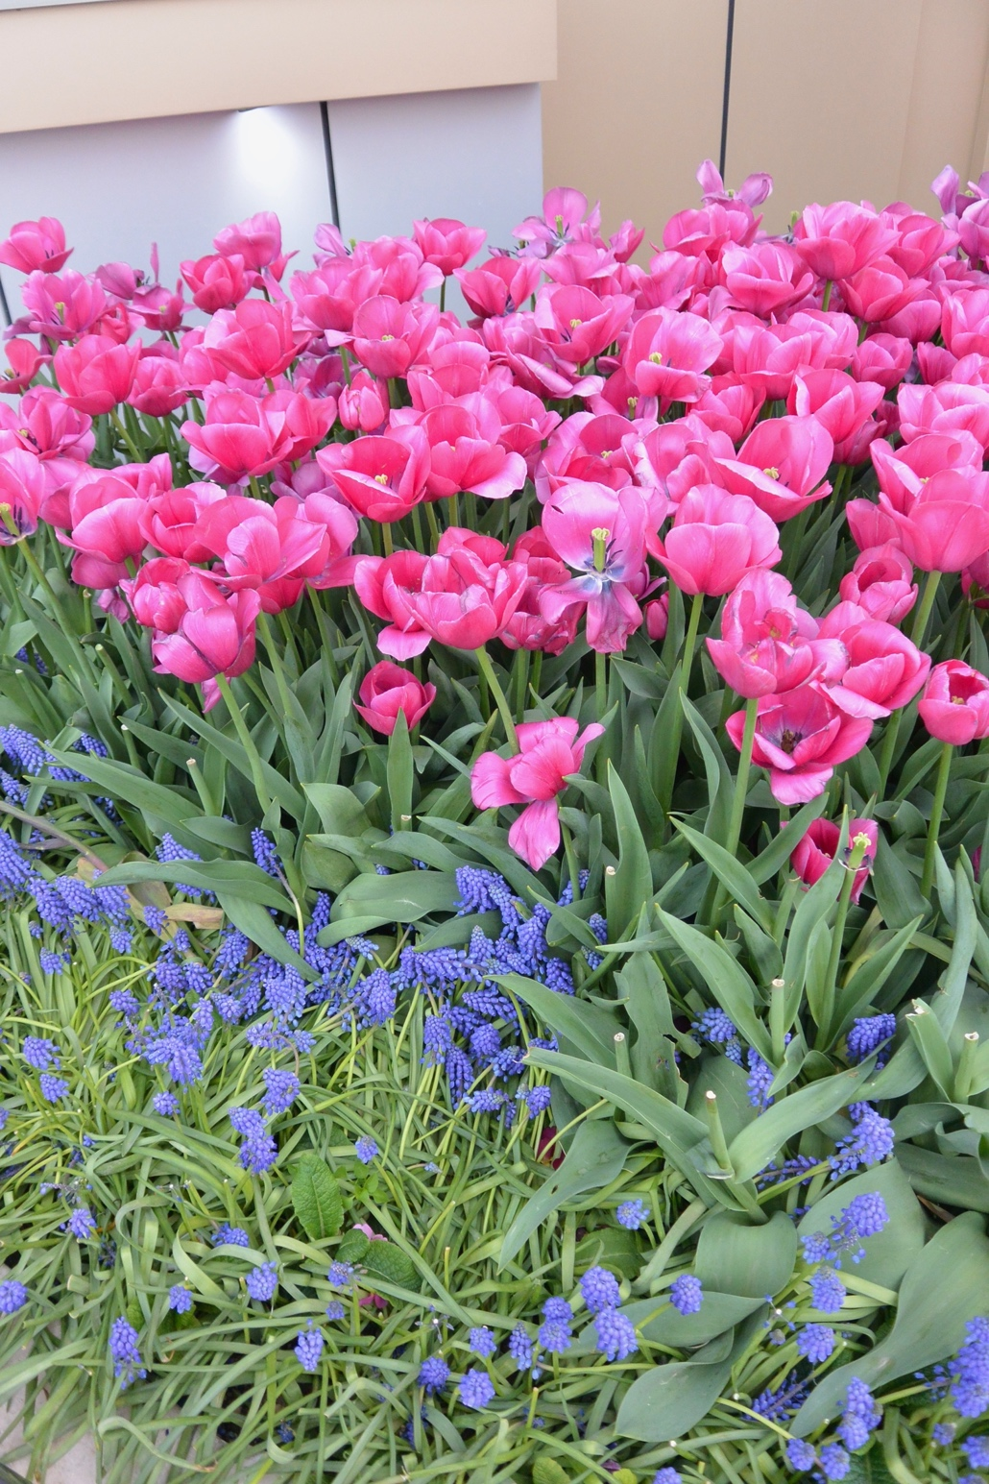

Westworth United Church
an Affirming Ministry located on the lands of
Treaty One Territory
and the homeland of the Red River Métis Nation

April 19th, 2026
Earth Day Sunday (Third Sunday of Easter)

Prelude

Welcome & Announcements

Introit

Call to Worship
Come all who seek the way of love,
To praise and worship the God of extravagant welcome,
Come all who seek vitality,
To praise and worship the God of abundant life,
Come all who seek relation,
To praise and worship the God of all Creation.
This and other service elements © 2026 The United Church of Canada/L’Église Unie du Canada. Licensed under Creative Commons Attribution Non-commercial Share Alike (by-nc-sa) Licence. (edited)

Prayer
We, as humans, are but one strand in a web of life, and only one being among many relations. As followers of Christ, we seek balance, the repairing of relations and to live with respect in Creation today and to the seventh generation. And we call on all people to do likewise, for the sake of Mother Earth, and in the name of the Creator. Amen.

Hymn VU 229 God of the Sparrow ROEDER

Prayer of Confession
God of the whole human race. You have given us responsibility to care for each other. But we have exploited and hated each other by our wickedness. We turn to you in sorrow and repentance. Please help us to look to you and care for each other.

God you are our creator, the source of all wisdom and power. You have created humans and animals and you have appointed us humans to be responsible for them. Forgive us who destroy your creatures. We turn to you in sorrow and repentance. Help us Lord to love and to care for them as you care for us.

God, in your mercy, hear our prayer. Amen.
From a lament written by members of the four Religious Orders in the Anglican Church of Melanesia (adapted)

Assurance of Grace

Sung Response VU 958 Halle, Halle, Halle CARIBBEAN

Passing the Peace
May the Peace of Christ be with you
And also with you.

Sharing the Story

We Hear the Word

Scripture: Genesis 1: 20-22; Genesis 2: 8-17
Hear what the Spirit is saying to the church.
Thanks be to God.

Scripture: Luke 6: 47-49
This is the good news of the Gospel.
Thanks be to God.

