Reflection

Hymn MV 150 Spirit God, Be Our Breath Bruce Harding

We Respond to the Word

Offering Invitation

Offertory VU 179 Hallelujah, Hallelujah Give Thanks (chorus only)
ALLELUIA NO 1

Offering Dedication

Prayers of the People and the Lord’s Prayer
Prayer Cycle: Elgin, God’s Lake – God’s River, Pinawa

Hymn VU 625 I Feel The Winds of God KINGSFOLD

Blessing and Benediction

Sung Amen VU 974 Amen Jim Strathdee
Postlude Voluntary in G Henry Heron


Reader: Dorcas Windsor
Pianist: Megan Dufrat
Director of Music: Valdine Anderson
Minister: Tricia Gerhard QR Code for Westworth donations

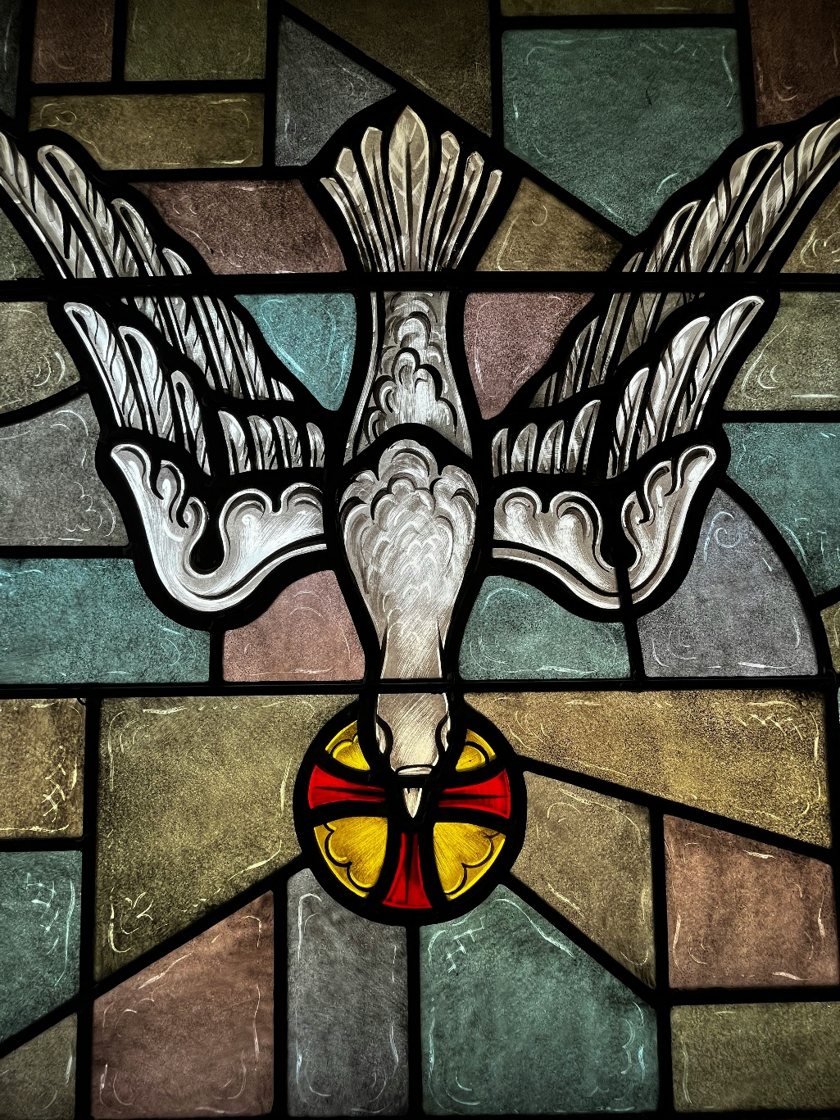

Westworth United Church
an Affirming Ministry located on the lands of
Treaty One Territory
and the homeland of the Red River Métis Nation

May 24th, 2026
Pentecost Sunday

Welcome & Announcements

Introit This is the Day Dorothy Lawson

Call to Worship
Everywhere God,
Move, swirl, dance among us. Remind us that you are always present: encouraging, inspiring and nudging us to be the loving people you call us to be. Gather us together in this time and place so that we might be witnesses to your spirit, working in and through us each day, every day. Amen.

Opening Prayer:
Holy One, for all the way you speak to us – in rushing wind, in dancing flames, in words we understand and in all that goes beyond language, we give thanks. Give us courage through our worship today to speak your love, everywhere we go, to everyone we meet. Amen.

Hymn VU 381 Spirit of Life (x2) SPIRIT OF LIFE

Prayer of Confession
You call us to be your voice in this world
And we stay silent.
You call us to be your hands in this world.
And we keep them hidden.
You call us to be your feet in this world,
And we go our own way.
When we meet those who are doubting
And say nothing, forgive us.
When we meet those who need your touch
And do nothing, forgive us.
When we are called to love one another,
And say nothing, forgive us.
Breathe life into our bones
Bring freedom to our lives
So that we might declare
With heart and soul and voice
That you are with us, always.
Amen.

Assurance of Grace

Sung Response MV 156 Dance with the Spirit Jim Strathdee

Sharing the Peace
May the Peace of Christ be with you
And also with you

Sharing the Story

We Hear the Word

Scripture: Psalm 104: 24-35 (VU827 – part two, refrain 1)

Scripture: Acts 2: 1-21
Hear what the Spirit is saying to the church.
Thanks be to God.

Anthem I Dreamed of Rain Jan Garret, arr. by Larry Nickel

Prayer adapted from one written by John Birch, and posted on Faith and Worship (http://www.faithandworship.com/) found on www.re-worship.blogspot.com

