So that they might nourish us body and spirit,
Giving us the courage to reflect Jesus’ love
Back into the world.

Knowing that we are not alone in this world,
We offer our prayers in these moments of silence
For a world that is hurting,
A world that is healing,
For people who are waiting
For people who are living
For people who are grieving
And for people who are celebrating.
These prayers and others that linger in our hearts and minds, we offer to you now…

These are our prayers,
And we lift them to you while joining our voices together
In speaking the words of the prayer Jesus taught:
Our Father…

Breaking the Bread, Filling the Cup
The Bread of Life, given for all
Thanks be to God.
The Cup of Love, given for all
Thanks be to God.

Distribution of the Elements

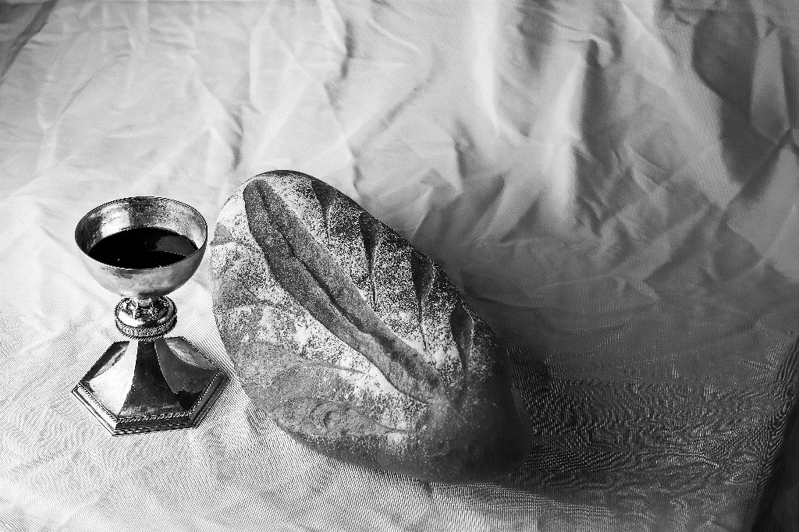

Invitation

The Great Thanksgiving

God is with you
And also with you
Lift up your hearts
We lift them up to God.
Let us give thanks to God, our God.
It is right to give God thanks and praise.

From the beginning darkness, God,
You have been present.
You have been with your creation,
Seeing it at it’s best,
Seeing it at it’s worst.
You have seen us at our best
You have seen us at our worst
When one of the first humans turned on a sibling,
When nation turned again nation,
When refusals led to false accusations,
When greed and want overcome love and care,
When people stopped seeing the other
as one your beloved ones
When we believed that the only way to solve a problem
Was to destroy it
You have seen us at our best
You have seen us at our worst
Forgive us our wrongs, God.
Great and small.
But even when the wrongs felt overwhelming and numerous
You did not abandon us, God!
Even in the worst of our moments,
You kept calling us back to your love,
Through grandparents and elders
Through activists and pacifists
Through prophets and priests
Through the ordinary and the extraordinary
You kept calling us back to your Love.
Hallelujah, God of all.
And then you sent us Jesus,
The human incarnation of your love.
Born like us. Grew like us.
Laughing and crying and loving and grieving like us.
And he too called us again and again to your love.
Not only with his healing acts
Not only with his teaching,
Not only with his welcome and ministry
But with his life.
His living and his ministry challenged his disciples,
his followers, his friends, his enemies
to love so much that the life God desired for us-
The life abundant for all.
With gratitude for this ministry, this love,
We proclaim:
Holy, holy, holy God, God of power and might
Heaven and earth are full of your glory,
Hosanna in the highest!
Blessed is the one who comes in the name of God!
Hosanna in the highest!
On the night before Jesus died…
…Remember me.”
So we eat and we drink and we remember
And we speak the mystery at the heart of our faith:
Christ has died, Christ has risen, Christ will come again.

Holy One, send your Spirit upon this bread and cup,
So that they, and we,
would be symbols of Christ’s life and death.
Let this be a moment in which we are filled
With the desire for justice and radical welcome.
Send your Spirit upon these simple things,

