Special Music Prelude in C Major by George F Handel with Fairest Lord Jesus by Rick Foster Arranged by Rod Machovec and Barbara Roberts

Reflection

Hymn MV 145 Draw the Circle Wide Gordon Light, Michael Bloss

We Respond to the Word

Offering Invitation

Offertory VU 218 We Praise You, O God (verse 1 only) KREMSER

Offering Dedication

Prayers of the People and the Lord’s Prayer

Hymn VU 626 I Heard the Voice of Jesus Say KINGSFOLD

Blessing and benediction

Sung Amen VU 974 Amen Jim Strathdee

Postlude I Heard the Voice of Jesus Say arr. Faye López


Reader: Vinny Ashton
Guitarist: Barbara Roberts
Pianist: Megan Dufrat
Director of Music: Valdine Anderson
Coordinator for Children, Youth & Families: Rachael Doerr
Minister: Tricia Gerhard QR Code for Westworth donations

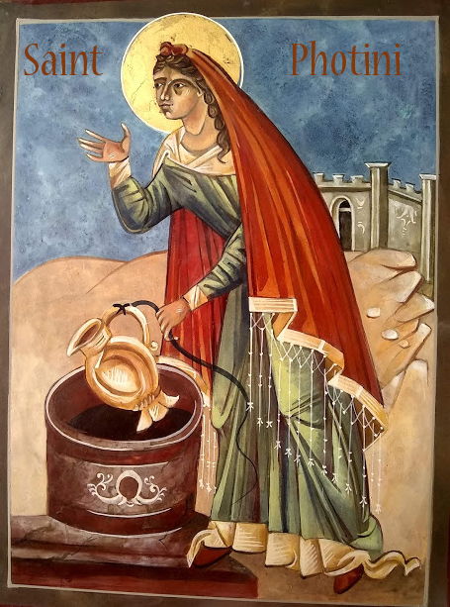

Westworth United Church
an Affirming Ministry located on the lands of
Treaty One Territory
and the homeland of the Red River Métis Nation

July 19, 2026
Bad Girls of the Bible: The Woman at the Well

Welcome & Announcements

Congregational Introit MV 61 I Praise You, O God David Robertson

Call to Worship
Turn the tap and water comes out.
Clean, refreshing water quenches our thirst.
Cool clear water with just the turn of a cap.
Water crosses our lips,
And our craving is satisfied.
Rain on a summer day, children standing with mouths wide
open.
The drops dampen our faces,
Nourishes the earth.
Jesus says
“everyone who drinks of this water.
Will be thirsty again.”
After a time, we all thirst again.
“but whoever drinks from the water that I will give
Will never be thirsty again.
The water I give will become in those who drink it,
A spring of water that bubbles up into eternal life.
We yearn for this kind of water,
So that we may never be thirsty again.
Come see the one
Who turns our thinking and our world upside down.
Come and experience
The love that knows no bounds.
Praise be to God!
Praise be to Jesus,
Whose life draws from the well of God’s dreams.
Praise be to Jesus,
Whose love and justice quenches our thirst
With living water.
Let us worship knowing that our thirst will be lessened by the living water of God’s word and presence. Amen and amen.

Hymn VU 375 Spirit, Spirit of Gentleness SPIRIT OF GENTLENESS

Prayer Seeking Reconciliation
God of Living Water, you call us to come and drink.
So why do we sit here and complain that there isn’t enough water?
You call us to strike the rocks of our world and let your
Living Water flow.
But we do not trust enough that the spring is there.
We want to find the water on our own, using our own wisdom.
You call us to share the Water of Life with the world around.
But we believe that the water is limited,
Not abundant and so we are tempted to save it for ourselves.
For all the times we turn away from your Water,
For all the times we sully the Water by misusing it,
For all the time we let others go thirsty instead of offering
drink.
Forgive us we pray.

Assurance of Grace

Sung Response MV 97 Listen, Listen God is Calling trad. song Tanzania

Passing the Peace

Sharing the Story

We Hear the Word
Scripture: John 4: 4-30
Hear what the Spirit is saying to the church.
Thanks be to God.

