Offertory VU 218 We Praise You, O God (verse 1 only) KREMSER

Offering Dedication

Prayers of the People and the Lord’s Prayer

Hymn MV 144 Like A Healing Stream Bruce Harding

Blessing and benediction

Sung Amen VU 974 Amen Jim Strathdee

Postlude Toccata in C Major Johann Pachelbel


Reader: Colleen Watters
Soloist: Trudy Blight
Pianist: Megan Dufrat
Director of Music: Valdine Anderson
Coordinator for Children, Youth & Families: Rachael Doerr
Minister: Tricia Gerhard QR Code for Westworth donations

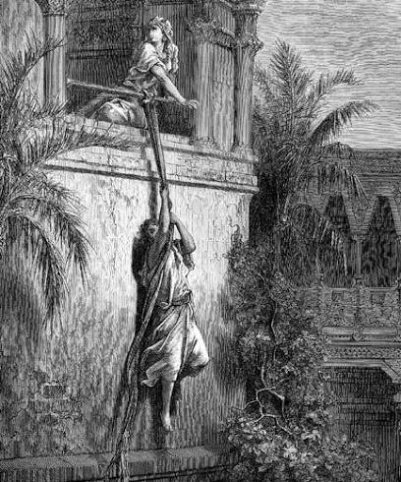

Westworth United Church
an Affirming Ministry located on the lands of
Treaty One Territory
and the homeland of the Red River Métis Nation

July 26, 2026
Bad Girls of the Bible: Michal

Welcome & Announcements

Congregational Introit MV 85 Take, O Take Me As I Am John L. Bell

Call to Worship
Come, let us worship the God of friendships and rising kings
The God of Jonathan’s loyalty, of David’s courage, of stories told and retold in sanctuaries worldwide.
Come, let us worship the God who sees Michal –
The one who loved first, who saved a life through a window in the dark, and who was never asked how she felt.
Let us worship a God who does not only remember the victors.
Let us worship the God who remembers the forgotten.
So come, with the stories you tell about yourselves, and the ones you don’t.
Come, let us worship the One who sees the whole story, and loves in each twist and turn.
And so let us worship, as a community of God’s stories.

Opening Prayer

Hymn VU 402 We Are One (v.1,2,4) WE ARE ONE

Prayer Seeking Reconciliation
God, you see what we overlook, we confess that we often stand where the crowd stood in Michal’s story – so caught up in the dancing king that we don’t think to look up at the window, so quick to celebrate the ones who rise that we forget to ask who was forgotten along the way.
We confess we have a habit of deciding, too fast, whose anger is righteous and who is just being “difficult,” whose grief deserves sympathy and whose is an inconvenience to a story we’d rather keep simple.

We confess the Michal’s in our own lives and in our community – the ones who showed up for us, protected us, believed in us – whom we quietly set aside once we no longer needed them, whose names we let fade first from our sight and then from our memory.

God, see the places where we have mistaken power for goodness,
where we have let usefulness stand in for worth, where we’ve stayed
silent because the truth was inconvenient. Hear as we pray,

Assurance of Grace

Sung Response

Passing the Peace

Sharing the Story

We Hear the Word
Scripture: 1 Samuel 18: 20- 29, 1 Samuel 19: 11-18, 2 Samuel 3: 1, 12-16, 2 Samuel 6: 12-23
Hear what the Spirit is saying to the church.
Thanks be to God.

Reflection

Hymn VU 697 O For a World AZMON

We Respond to the Word

Offering Invitation

Special Music Domine Deus (Gloria) Vivaldi

