We find peace this day knowing no matter how we pray or when we pray, our deepest concerns and yearnings find you and you hold them close, listening to us. With Christ, in Christ and through Christ, in the power of the Holy Spirit, all glory is yours God most holy, now and forever. Amen.

We join our voices together to boldly speak the words of prayer that Jesus taught:
Our Father…
Distribution of Elements
The body of Christ, broken for you
Thanks be to God for the bread of life.
The cup of Christ poured out for you
Thanks be to God for the cup of blessing

Receiving the Elements

Prayer after Communion
God of community, we rejoice for all that we have been given at this table. May the prayers we’ve said, the Spirit we’ve felt, the Power that we’ve come to trust move in us as we move forward in our worship so that we may live as your people this day and always. Amen.

Communion September 6, 2026

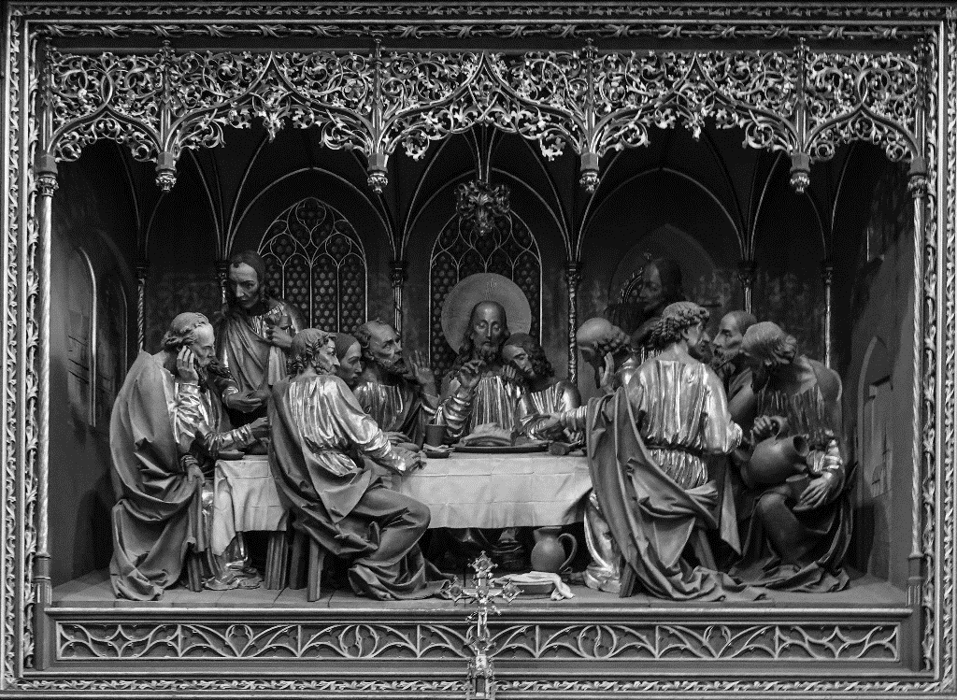

Sharing Communion

May God be with you
And also with you
Lift up your hearts
We lift them up to God.
Let us give thanks to God
It is right to give our thanks and praise.

Thanks be to you Holy God, awesomely distant -
Thank you for the searing of shooting stars
For the colours of planets in the night sky
For the space and power beyond our perceiving
For the presence of your Spirit that sets the heavens in motion.

Thanks be to you God, unbelievable close –
For giving life to dreams long forgotten,
For shedding light upon those places
we are too afraid to see,
For calling us to grow into the people you created us to be.
Both the dance of pure stillness
and the beating of our hearts are your doing.
And so we join our voices with all the voices
Of those who have before us, saying
Holy, holy, holy Lord
God of power and might
Heaven and earth are full of your glory
Hosanna in the highest
Blessed is the One who comes in the name of the Lord
Hosanna in the highest.

Thanks be to you God, known in the form
of Jesus of Nazareth
who came to walk this road before us
who blessed the sinner as soon as the saint
who called to those the world would shut out

who invited us to know you more deeply through his living.
Reaching out for your kingdom of peace
And light she showed us your love.
Dying on the cross he suffered as so many suffer
Rising from the dead he placed new life within our grasp.

As we remember his birth, his life, his words and wonders,
His death and his love,
We speak of that mystery we call faith:
Christ has died, Christ has risen, Christ will come again.
Life giving God, you call us to remember that
On the night before Jesus was betrayed,
He had supper with his disciples.
He took bread, gave thanks and broke it;
Giving it to his friends, he said:
“Take this and eat. This is my body, given for you.”
After supper he took the wine;
He gave thanks to God for it,
And passing it to his friends, he said:
“This is my blood, a sign of the new covenant,
Poured out for you and all people.”

As we gather around this Holy Table, we pray that you would pour out your Spirit upon the bread, the cup and all of us who come longing for your love and hope in our lives.
May the bread which has been broken shape us as servants in a world shattered by injustice and hopelessness. May the cup we share reform our hearts so we would hear the cries of the lost, the last and the least;
As we are embraced through your grace, may we be reborn, not as saints who can bask in our own glory, but as servants who seek to be your hands and feet in this glorious world.
As we feel your Spirit move, we remember all those who long for your healing and your hope. We offer to you, in the silence, the prayers of our hearts, minds and souls…

