The Peace of Christ

Sharing the Story

We Hear the Word

Scripture: Genesis 1: 26-31 (from the Inclusive Bible)
Hear what the Spirit is saying to the church.
Thanks be to God.

Scripture: Matthew 5: 21-26
This is the good news of the Gospel.
Thanks be to God.

Anthem

Reflection

Hymn MV 150 Spirit God, Be Our Breath Bruce Harding

We Respond to the Word

Offering Invitation

Offertory VU 218 We Praise You, O God (verse 1 only) KREMSER

Offering Dedication

Four Directions Prayer

Hymn VU 678 For the Healing of the Nations WESTMINSTER ABBEY

Benediction

Closing Prayer Song

Special Guests: Jeremy Raven & Holly Loest

Readers: Marion McKay, Barbara & Frank Wynes, Christine Strike
Pianist: Megan Dufrat
Director of Music: Valdine Anderson
Coordinator for Children, Youth & Families: Rachael Doerr
Minister: Tricia Gerhard

Sakihitowin (Sah-gi he-toh-win) – Love, Kindness, Community
Tapwe (Tah-pway) - Truth

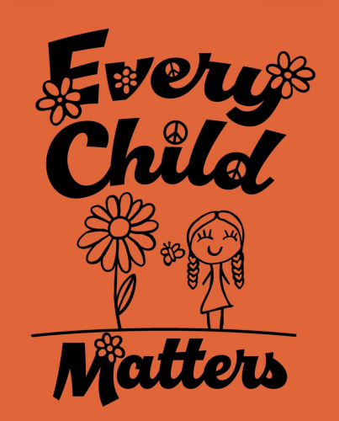

2026, by Emily Galeazzi
Grade 2 student from Coldstream, BC

Westworth United Church zhi-kagige-aniishag, nindoodem Treaty No. 1 gii-aniishin, Anishinabe (Ojibwe), Ininew (Cree), Anisiniew, Dene, mii ottawa Dakota akina. Mii naadamaadwin Métis Nation nindizhinowin, bihkikwe Métis Nation aazhoon.

September 27, 2026
National Day for Truth and Reconciliation/Orange Shirt Day

We Gather to Worship

Welcome

Opening Song

Acknowledging the Land

Introit Sakihitowin Andrew Balfour

Opening Prayer
Creator,
You made heaven and earth, the sea, and all that is in them.
You made us as people, as communities, and as families.
You intend for us to grow and flourish together.
You command us to do good works, to be generous, and to build a good life for all.
Some of us wear orange today to say we did not always experience what you want for us, because there were children taken from families and communities against their will.

Some of us wear orange today to say that Every Child Matters, and that we want to create a future that values all Indigenous peoples.

Our prayers today are not simple expressions of hope for justice, they are our continued commitment to create your justice on earth.

We pray today…
To acknowledge the harm caused by residential institutions and to honour all who were taken.
For the end of racial discrimination against Indigenous children.
For the humility to open ourselves to the task before us, and the courage to work together.
You tell us to build up a good foundation for the future, so that we might “take hold of the life that is really life.”
We wear orange today, and we commit to the life that you intend us to live together.

Hymn VU 400 Lord, Listen to Your Children Praying CHILDREN PRAYING

Prayer Seeking and Committing to Reconciliation
Creator, God, Source of Love,
Hear us as we pray, your people seeking reconciliation and yearning to
continue on the path of healing and building good relations with our
Indigenous siblings and cousins. Give us a sense of justice, give us an
awareness of new beginnings.

Creator, God, Source of Love,
We offer prayers of gratitude for the fact that each new days offers us the opportunity to start a new, to recommit to this journey we make as a church and people of faith.

Creator, God, Source of Love,
Guide us so that ancient and not so ancient wrongs may be redressed,
so that broken promises might be forgiven, and a new way forward, a good way forward may be forged. Open our minds, our mouths, our hearts, our whole being to your healing presence and may that healing presence be felt in all the hurting places of creation.

Creator, God, Source of Love,
Hear us as we pray, as we commit ourselves to the on-going work of reconciliation and the work of learning to be good relations. Draw us forward with the strength, compassion and courage needed to give ourselves to the ministry of reconciliation that you call us to.
This we pray. Amen.

Sung Response MV 79 Spirit, Open my Heart WILD MOUNTAIN THYME

Prayer adapted from one written by Sara Stratton, Reconcilitaiton and Indigenous Justice Animator. Found on https://united-church.ca/prayers/prayer-we-wear-orange
Prayer found in “Worship in the Vision of New Agape” published by the Anglican Faith, Worship and Ministry Committee and Anglican Church of Indigenous People in 2001

