Offertory VU 605 Jesus Teacher Brave and Bold OUGHTRED
(v2 with slight alteration)
Jesus friend so strong and true
Show us good brave work to do
Show us those who need a friend
All things broken, help us mend.
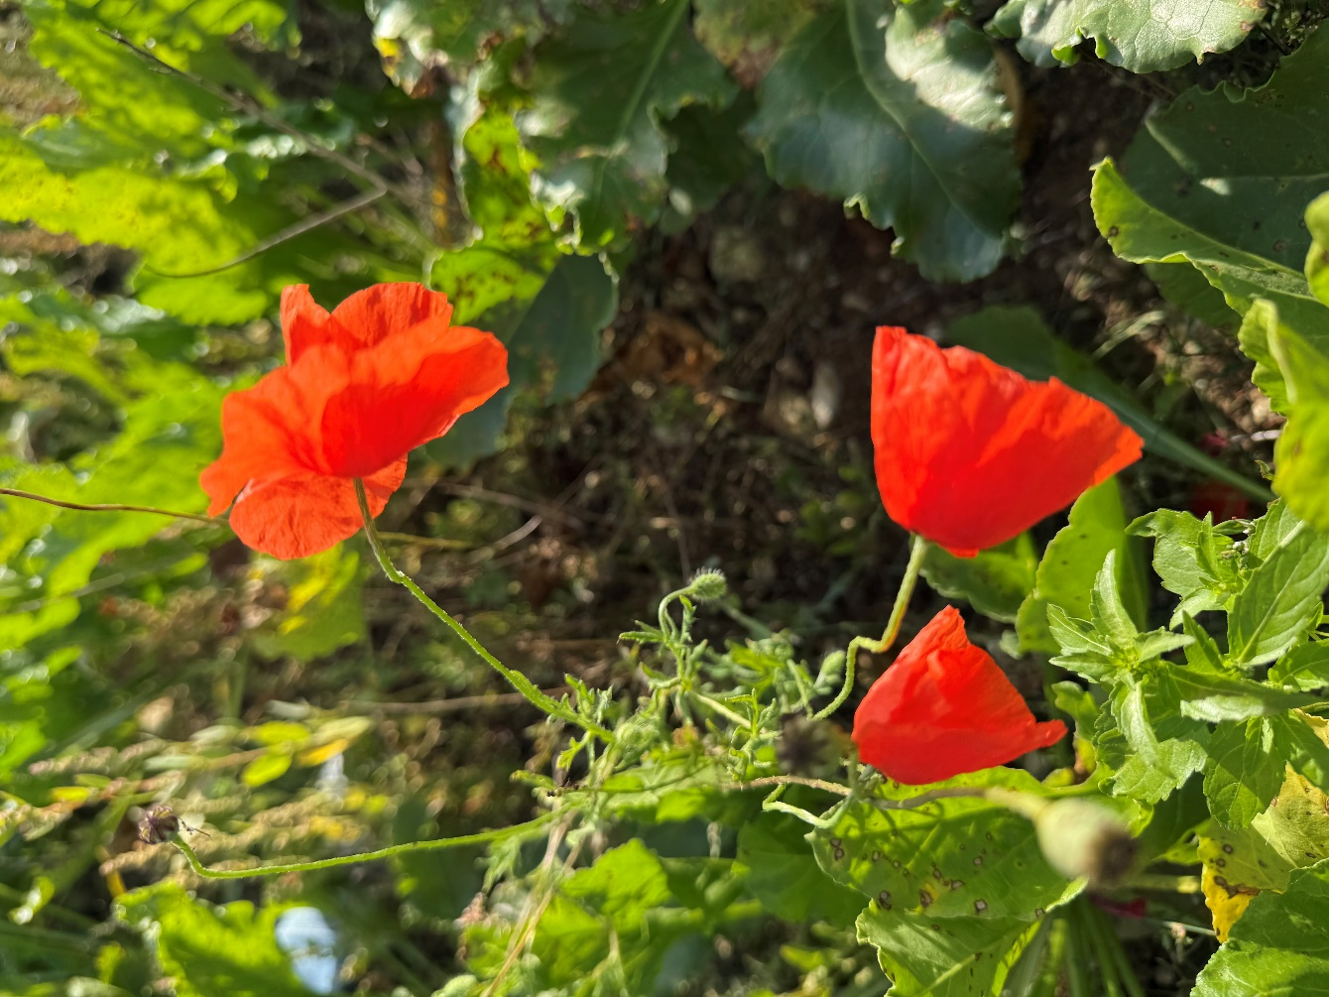
Bless these gifts and stretch our care,
Teach us to serve you everywhere.

Offering Dedication
Heart of my own heart, be my sight, be my song, be my light. Soften my heart that it would break for Your world. Lead my hands and feet to do work that is poured out for the sake of Your people. Bless what my hands offer here and through these gifts may Your church be brave and may it be a sign of Your Love in the world. This we pray. Amen.

Prayers of the Community

Hymn VU 697 O For a World AZMON

Sung Benediction Christ be with Me K. Lee Scott

Sung Amen VU 974 Amen Jim Strathdee

Postlude O God, Our Help in Ages Past arr. Healey Willan


Conductor of Westworth Winds: Ray McClelland
Reader: Glenda Oldham
Organist: Dorcas Windsor
Director of Music: Valdine Anderson
Coordinator for Children, Youth & Families: Rachael Doerr
Minister: Tricia Gerhard

Cover Photo: Kathy McPhail
Poppies from the Battlefield in France, 2026

Westworth United Church
an Affirming Ministry located on the lands of
Treaty One Territory
and the homeland of the Red River Métis Nation

November 8th, 2026
Remembrance Sunday – Unexpected Jesus: Prince of Peace.

We Gather to Worship

Prelude Westworth Winds

Welcome & Announcements

Introit Come, Peace of God Eugene Butler

Call to Worship
We gather in this house of prayer to embrace the peace Jesus came to offer the world.
We gather in this house of hope to weave the peace of Jesus into the everyday moments of our living.
May our worship be a time where peace moves in close.
May our prayers for peace today take root in our hearts and in our world.

Opening Prayer (see insert)

Hymn VU 34 Come Now, O God of Peace O-SO-SO

Ritual of Remembrance

Words of Remembrance

Pictorial Memories – Westworth Winds

Last Post
…
We will remember them
We will remember them.

Minute of Silence

Reveille
They were young, as we are young
They served, giving freely of themselves.
To them, we pledge, amid the winds of time,
To carry their torch and never forget.
We will remember them.
We will remember them.

Hymn VU 527 God! As with Silent Hearts ST AGNES (LANGRAN)

We Hear the Word

Scriptures: John 14: 25-27, John 16: 33, Matthew 5: 9, Romans 12:18,
Colossians 3:15, 2 Thessalonians 3:16, Isaiah 52: 7
These are the stories of our faith.
Thanks be to God.

Anthem In Flanders Fields Eleanor Daly

Sermon

Hymn VU 684 Make Me a Channel of Your Peace CHANNEL OF PEACE

Sharing the Peace of Christ

We Respond to the Word

Offering Invitation

Written by Rev. Richard Bott. Gathering, Pentecost 2 2025, page 47 Used with permission

